Biological Grounds of Success of the Arctic Copepod Calanus glacialis
at the Species Range Margin in the Sub-Arctic White Sea (66° N)

Daria M. Martynova*¹, Nikolay V. Usov¹, Vadim M. Khaitov^{2,3}, Inna P. Kutcheva¹, Svetlana A. Murzina⁴

¹ Zoological Institute, Russian Academy of Sciences, St.Petersburg, 199034, Russia
2
3
⁴ Institute of Biology, Karelian Research Center, Russian Academy of Sciences, Petrozavodsk, 185910, Russia

*corresponding author daria.martynova@gmail.com

Abstract
In the White Sea Calanus glacialis annual vertical distribution, feeding and reproduction peculiarities, as well as lipid dynamics through the year are governed by both temperature and feeding conditions. The life cycle of this species tends to prolong up to four years, with two obligatory years. The females are highly dependent on the food sufficiency during the reproduction period. C. glacialis in the White Sea may employ omnivorous feeding comparing to this species, described as predominantly herbivores in the high Arctic. The most vulnerable developmental stages are CIII and CIV copepodites, which face with food limitation in the first summer due to mismatch between the delayed molt and hydrological regime of the White Sea. The CIV copepodites then feed in the end of the summer, when temperature of productive upper water layers decreases, and thus complete lipid storing successfully. The scenario of global warming impact on the species biology is discussed, basing on high species flexibility and adaptation to adverse environmental factors in the White Sea.

Keywords: Calanus glacialis, the White Sea, life cycle strategies, feeding, reproduction, lipids

INTRODUCTION
The White Sea is a semi-closed sub-Arctic region, which exhibits the features of both Arctic and temperate waters and is characterized by the lower salinity ranging 25—28 psu (Berger et al. 2001). The surface water temperatures may reach +20 °C in the summer period, averages as +12…+14 °C (Berger et al. 2003), while the other sub-Arctic areas are characterized by significantly lower temperatures, which do not exceed +6…+8 °C (Coachman, Aagard, 1974). The period of coincidence of high primary production and low temperatures in the White Sea is shortened greatly, when the surface layer water temperature increases up to +10 °C in 6-8 weeks after the ice melt. The cold-water epipelagic copepods, inhabiting the White Sea, have to deal with such mismatch of the favorable conditions period and duration of certain life stages.
In the Arctic seas, C. glacialis is described as a species with various life spans, which may finish its life cycle in one calendar year overwintering south of the polar front (Conover 1988), for example, in the Greenland Sea (Smith 1990), the Davis Strait (Huntley et al. 1983), and the Sea of Okhotsk (Safronov 1984); or it may live up to three years in the northern areas (Conover 1988) and in the White Sea (Kosobokova 1998, 1999). Generally, the scheme of the life cycle is similar for all the areas and includes spring reproduction, summer growth and moulting to elder copepodite stages with simultaneous lipid storage and overwintering as a diapausing copepodite accompanied by food-independent moulting to mature stage (Conover, Huntley, 1991). The overwintering may occur once or up to three times depending on length of the productive period, which is closely connected with the region latitude, e.g. sunlight and ice regime (Falk-Petersen et al. 2009). The populations inhabiting southwards off the Polar Circle have more chances to finish their life cycle in one year, and life cycle span increases northwards (Conover 1988; Falk-Petersen et al. 2009).
Calanus glacialis is one of the key copepod species in the White Sea, substituting up to 70% of total zooplankton biomass, especially in the deep areas (Berger et al. 2001). It was introduced by income of the Barents Sea waters after last glacial period and forms here an isolated population from the other Arctic seas for the last 5,000 years (Pertzova and Pantyulin 2005; Choquet et al., 2018), characterized by quite pronounced tolerance to low salinity at certain copepodite stages (Martynova and Ivankovich, 2020). The life cycle of Calanus glacialis in the White Sea is considered to be biennial, overwintering as diapausing CIV (first winter) and CV (second winter) copepodites (Prygunkova 1968, 1974), with possible third overwintering as a female stage (Kosobokova 1998, 1999). Gonad maturation, sexual differentiation and moulting to adults take place during the second year of development. The following autumn/winter is the major period of CV maturation, which occurs independently on food supply. The onset of female maturation occurs in February and March, ca. 2 months prior to the spring phytoplankton bloom. Reproduction takes place between April and June. It terminates in the second half of June and coincides with the warming of the surface water layer where egg laying is observed. Females of C. glacialis may survive for several months after reproduction and are able to winter again (Kosobokova 1998, 1999).
Calanus is assumed to have different feeding activity through the year, as the other species with winter diapause. However, the feeding patterns of C. glacialis in the White Sea were studied quite occasionally and fragmentary. Only several outdated publications may be named, mostly for CIV-CV copepodites in the summer period (Perueva 1977a, 1977b, 1984), fed sometimes on algal monocultures (Arashkevich and Drits 1984; Sergeeva and Arashkevich 1991), all in Russian. Nearly nothing is known about the annual feeding activity of different developmental stages on natural seston. The female genital development and some reproductive peculiarities of this species in the White Sea was described by Kosobokova (1993, 1998, 1999), however, no experimental assessment of food impact to gonad maturation and reproduction success of this species was applied so far in this area. Data on lipid biology of C. glacialis in the White Sea is quite scarce, describing only total lipid content (Arashkevich and Kosobokova 1988; Kosobokova 1990). The data on the temperature preferences of this species and spring vertical distribution correspond only to several years of observation (Kosobokova 1998, 1999). The scarcity of complex data on C. glacialis annual vertical distribution, temperature optima, feeding patterns, lipid and reproduction biology in the White Sea does not allow accurate comparing this local population with the rest, inhabiting the Arctic waters.
The species biology in the White Sea described earlier testified for general similarity of C. glacialis population in the White Sea with the populations inhabiting other Arctic areas (Weydmann et al., 2016), but these results suffer from large gaps in seasonal and multi-year data and detailed description of the very mechanisms of the species success at the species range margin. The present study aimed to fill in the missing gaps and to describe essential biological and ecological peculiarities of Calanus glacialis inhabiting the White Sea, e.g. to study annual distributional and feeding patterns, lipid dynamics and early genital development in regard to the food availability, and to perform the multivariate analysis of C. glacialis seasonal cycle in order to assess the biological grounds of its success in the sub-Arctic sea.

MATERIALS AND METHOD

Hydrology, seston and zooplankton sampling
The seasonal dynamics of temperature, salinity, and vertical distribution of different developmental stages of Calanus glacialis in regard to environmental conditions has been studied in the Kandalaksha Bay, the White Sea (Table 1). The sampling and zooplankton counting were performed by standard methods (Zhadin 1960; Tsyban at al. 1981; Harris et al. 2000). The zooplankton was sampled by Juday net with 0.1-m² opening diameter (Table 1). The samples were immediately preserved with formaldehyde (final concentration 2–4%) and concentrated down to 100-mL or 200-mL volume according to the total zooplankton abundance assessed visually. Three 1-mL aliquots were taken from concentrated sample using a Hensen stempel pipette. The counting was performed in the Bogorov's counting chamber for the copepodite stages exceeding 10 ind. per mL; the other stages were counted totally in the entire sample. The abundance was expressed as a number of specimens per one cubic meter (ind. m⁻³).
Commonly accepted abbreviations of copepodite developmental stages are used in the text: CI—CV are the immature copepodite stages I—V, CF are females. Males were presented singly and were not considered for any analysis.

Fig. 1. Study area. - перевести названия
Table 1. Sites of zooplankton sampling
Station no. | Depth, m | Coordinates | Study period | Sampling periodicity | Mesh size | Zooplankton sampling
D-1 | 65 | 66^{о}19.8ʹ N, 33^{о}39.7ʹ E | 1961—2019 | Year round, every ten days during ice-free period and monthly from the ice. | 200 μm | 0-10 m  10-25 m  25-65 m
D-1 | --"-- | --"-- | 1998—2019 | --"-- | 100 μm | --"--
D-3 | 210 | 66°26.1' N, 33°55.1' E | 2012—2019 | Once a month from May through November (ice-free period), some gaps occurred. | 200 μm  and  100 μm | 0-10 m  10-25 m  25-50 m  50-100 m  100-200 m

Water temperature and salinity were measured simultaneously to the zooplankton sampling. During the period of 1961–2006, the water temperature was measured by reversing thermometers mounted on the Nansen bottle (BM-48, USSR) at the standard depths of 0 m, 5 m, 10 m, 15 m, 25 m, 50 m, and near the bottom (65 m) or by bathythermograph GM7-III (USSR). Salinity methods before 2006. Since 2006, the water temperature and salinity were measured by CTD probe MIDAS CTD+ (Valeport Ltd.) as continuous profiles from surface to bottom. Prior to use of next generation gear, CTD was intercalibrated with reversing thermometers and bathythermograph. No significant discrepancies were found within the limits of accuracy of the previously used equipment.
The seston sampling was performed during 2000-2008 at station D-1, major characteristics (dry weight, Chl a, C_{org}, and N_{org}) were analyzed at the standard depths (see above) simultaneously with zooplankton sampling. Filters with seston were immediately placed to 90% aqua acetone (Evans et al. 1987) after filtering for further analysis of Chl a and phaeophytine (here and further phytopigments); standard analytical methods have been applied (Bathmann, Liebezeit 1986). Prior to CN analysis, filters were gently washed with 3—6 drops of 1N HCl to remove all inorganic C, rinsed with 10 mL distilled water under 0.4 Pa vacuum and dried for 24 h at +54 °C to constant weight. Organic C and N content was measured at Carlo Erba NA 1500 Analyzer using standard techniques in the Department of Biological Oceanography, Alfred-Wegener Institute (Bremerhaven, Germany). Pigment per carbon ratio (PPC, µg µg⁻¹) was calculated according to Harris et al. (2000).

Cephalosome measurements
Cephalosome length and width of CIV—CF were measured under the microscope with 0.05-mm accuracy in order to find the differences between the cohorts (generations) and thus to search for possible prolongation of the life cycle on this species at these particular stages, as evidenced for C. hyperboreus (Ji et al., 2012). In total, 1,483 individuals have been measured, sampled at station D-1 from February through July, 2005—2008. Cephalosome length (L_{c}), width (W), and L_{c}/W ratio for each stage and layer were compared with Student t-test.

Feeding
Feeding was studied in the series of the experiments in different seasons of 2005—2008. Zooplankton was sampled at station D-3 by Juday net (100-μm mesh size, 0.1-m² opening) by vertical tows from 0—25-m and 25—bottom water layers. The samples were diluted by fresh seawater taken by 5-L Niskin bottle from depth of 0 ºC water temperature, placed in 2-L Pyrex glass bottles in the Coleman box and immediately transported to the shore laboratory. The copepodites of prevailed developmental stage were sorted under the dissecting microscope and acclimated to the experimental conditions for at least 48 hours. From 10 to 20 specimens were placed in 1-L Pyrex glass bottles (4—6 replicates) filled in with the water from the fluorescence maximum, previously filtered through 200-μm mesh. The amount of the specimens used in one replicate depended on the copepod size, e.g. the number of large specimens placed in one vial was less than for the small ones. The copepods were incubated for approximately 24 h on the plankton wheel at 2.0 rpm in cooled dark container at 1.0±0.5 ºC. Three bottles without copepods were used as controls. At the end of the incubation, the copepods were checked (dead/alive/feeding), the entire bottle content was filtered through a 200-μm mesh sieve, and faecal pellets were counted under a dissecting microscope. After the experiment was terminated, 100 mL of water was fixed with buffered formaldehyde (2% final concentration) for further phytoplankton counting, and three 450-mL aliquotes were filtered under 0.3 Pa vacuum on precombusted borosilicate glass fiber filters Whatman GF/F for further analysis of phytopigments and CN content of POM (0.2—200-μm size group). After the experiments, the specimens were blotted dry, placed individually in polypropylene 1.5 mL Eppendorf cups, and then frozen and stored at –80 ºC for later biochemical analysis. The same procedure was applied to GF/F filters with seston.
Ingestion rates of POM in terms of organic C and Chl a were calculated assuming exponential growth and constant ingestion rates (Frost 1972; Tackx and van der Vrie 1985; Meyer-Harms 1996). Percentage of ingested phytoplankton as a part of total consumed organic C was calculated using PPC ratio (Harris et al. 2000).
The selectivity of phytoplankton species has been assessed by Utermöhl counting method. The phytoplankton cells and Tintinnidae in control (without copepods) and experimental bottles (with copepods) were counted for 100-mL sub-sample under standard techniques (Utermöhl 1958) at the beginning and at the end of experiment using DAPI as fluorescence marker. Particles in the samples of natural seawater were counted totally due to low concentration of phytoplankton in winter. Each phytoplankton species was subdivided into three groups: (1) intact "full" cells with chloroplasts; (2) intact "empty" cells without chloroplasts; (3) broken cells. Chain-forming phytoplankton species were considered separately as solitary cells and cell chains. Chaetoceros, Pseudonitzschia, and Thalassionema species were considered belonging to three size groups: (1) cells smaller than 50 μm; (2) cells of 50—100 μm, and (3) cells bigger than 100 μm (if applicable). Due to the fixation method, Diatomea, thecate Dinophyta, and Tintinnidae were preserved well enough to define the genera. Most of athecate Dinophyta need special fixation and processing by highly experienced personnel; thus, we did not analyze this group here. However, the PPC ratio was calculated in order to assess the ratio of non-algal food in the copepod diet (see above).
Primary data sorting was applied before the calculations of selectivity were performed. Only when certain phytoplankton species concentration in the beginning of experiment was not less than 50 intact “full” cells per liter, this species was further used for analysis. In order to determine whether the food concentration has changed significantly, Kolmogoroff–Smirnoff two-sample-test (Zar 1996) was applied for each species/genera/size group at p = 0.05. Differences in concentration of considered species between the beginning and end of experiment in control vials were assessed to verify for mortality or growth of each phytoplankton species. The same was applied for initial concentration of intact cells and final concentration of broken cells of the same species in vials with copepods. These corrections were applied for the final concentration in experimental vials. After incubation, difference between control and experimental vials (adjusted values) evidenced on consuming particular species/genera/size group at p = 0.05. In order to test whether the initial food composition differed significantly from the composition of the food ingested, Chi2-tests (Zar 1996) were performed for each experiment at p = 0.05. Only when p < 0.05, it was assumed that selective feeding occurred (Schwamborn et al. 2004). For such species, Chesson electivity index ("epsilon" e) was calculated (Chesson 1983). The values of e may range from -1 to +1, where a value of zero means no selection, "+1", 100% selection, "-1", 100% rejection. The index "epsilon" was obtained for each food item by calculating Manly's preference index, which considered food depletion during experiments (Manly et al. 1972). Manly's preference index was then transformed to the scale of "epsilon" using Chesson's equation (Chesson 1983), rather than using a linear transformation to the scale of "epsilon" (Schwamborn et al. 2006).

Gonad developmental (reproductive) state
Three series of the experiments on the gonad development were performed in March—April, 2008. The ice cover on March 15, 2008, was about 40 cm; however, the ice algae colonies were quite disperse (less than 2—3 colonies per 100 cm²). The number of colonies did not increase until the ice melting. Zooplankton samples were taken on March 16, 2008, by vertical tows of Juday net (35 m—surface) with hand winch from the ice at station D-1. The samples were placed in 2-L plastic vials pre-filled with natural seawater (5-m depth) and immediately transported in Coleman box to the shore laboratory. Calanus females were gently picked up with wide plastic pipette, prosome length and width were measured for each specimen. Gonad developmental state was determined by originally modified scale (Table 2) based on that suggested by Smith et al. (1990) and Kosobokova (1999). Females had different colouration: brightly coloured, or "red" (numerous red chromatophores were present on antennas, genital pores and gut) and "pale" (minor chromatophores or without any). Fifty females, selected randomly, were placed individually in 2-L Pyrex glass bottles filled with natural seawater (5-m depth, pre-sieved with 200-μm mesh). The bottles were gently turned upside down several times a day during the incubations to reduce settling of algae (Calbet et al. 2002); 500 mL were replaced every day by freshly taken and pre-sieved seawater as described above. The pellets were picked up and counted every day. The rest of females, 202 specimens, were placed in the 30-L container with filtered (GF/F, 0.2 μm) seawater. One half of the water volume was replaced every fifth day. The gonad developmental state both for starved and fed females was checked every fifth day. At the same day, or day before, the zooplankton sample was taken from the ice to compare gonad developmental state of natural Calanus population with animals under laboratory conditions. Unfortunately, rapid weather change (thaw) on March 30—31, 2008, resulted to impossibility to work from the ice due to quick ice melting. The seawater for the experiment then was taken from the fast ice edge. ANOVA/MANOVA analyses were applied in order to find the differences in gonad developmental state for fed and starved animals, as well as to search for effect of the colouration on the cephalosome dimensions and gonad state.

Table 2. Calanus glacialis female reproductive stages, with original modifications of Smith et al. (1990) and Kosobokova (1999)
Gonad state | Morphological description
G1, young immature | Only compact ovary visible, the diverticula are thin bands and widely separated from each other.
G2, immature | Small oocytes in the ovary, the diverticula are thin bands and widely separated from each other.
G3, semi-mature | Small oocytes in the ovary, single rows of oocytes are extending forward from ovary to diverticula. Medial walls of diverticula tend to force together.
G4, pre-mature 1 | Small oocytes in the ovary, rows of oocytes larger than in ovary are extending forward from ovary to diverticula. Single oocytes may be found in the oviducts. Medial walls of diverticula are very close to each other. Ovary larger than for state G3.
G5, pre-mature 2 | Oocytes of different sizes extending forward in diverticula. Medial walls of diverticula force together. More than one row of the oocytes are visible in the oviducts in the lateral view. Large oocytes are visible in the medial row in diverticula.
G6, mature | Large oocytes are densely packed in the diverticula and occupy much of the cephalothorax. Abutting medial walls of diverticula extend forward from ovary as a dark line to anterior cephalothorax. Large oocytes are visible in the oviducts in lateral view extending posteriorly to fifth thoracic segment.
G7-G9, Semi-spent, spent, re-maturing | Not observed

Biochemical analyses
The copepods for the lipid and CN analyses were taken simultaneously with the sampling of the animals for the feeding experiments and periodically during the monitoring activities at D-1 station (NOAA, https://www.st.nmfs.noaa.gov/copepod/time-series/ru-10101/). The samples were placed in 2-L plastic vials pre-filled with natural seawater (5-m depth) and immediately transported in Coleman box to the shore laboratory. Live copepods were sorted by developmental stages under the dissecting microscope in a Petri dish on the ice. Three to eight samples (1—15 animals of particular developmental stage each) were prepared for dry weight (DW), organic C and N analysis. Copepods were placed onto pre-weighed and dried GF/C filters (25-mm diameter, dried at 180 °C for 24 h), then the filters were gently washed with filtered seawater (1 µm) and with 3—5 mL of distilled water on the 0.1 Pa vacuum, placed onto the precombusted aluminium foil envelopes (180 °C, 24 h) and dried at 56 °C for 24 h. Filters were cooled at silica-gel down to the constant weight (room temperature) and then weighed with 0.01-mg accuracy. The rest of the animals in the live samples were immediately fixed for lipid and fatty acid analysis. Three replications, 15 to 50 freshly sampled copepods of particular copepodite stage each, were analysed for each sampling date. Copepods were taken with a wide plastic pipette and then placed to the pre-weighed 2-mL polypropylene Eppendorf cups, pre-washed with dichloromethane:methanol (2:1, v:v), hereinafter, DCM. Copepods were gently washed with cold distilled water and then dried on the Kleenex tissue. In each cup, 1.5 mL of DCM has been added; five cups with the same volume of DCM without copepods at each sampling date were treated as blank samples. The animals were immediately frozen at –30 °C and stored at these conditions until analysis (Falk-Petersen et al. 1987; Tande and Henderson 1988). In females, the gonad state was noted (Table 2). Lipids were extracted according to Folch et al. (1957). The fatty acid and alcohol compositions were determined by gas chromatography (Kattner and Fricke 1986). Briefly, lipids were hydrolysed in 97% methanol:3% concentrated sulphuric acid; fatty acids were converted to methyl esters by trans-etherification at 80 °C for 4 h. Fatty acid methyl esters and free alcohols were then analysed by a gas liquid chromatography (Agilent 6890N Network Gas Chromatograph) on a 30 m × 0.25 mm i.d. wall-coated open tubular column (0.25-µm film thickness; DB-FFAP liquid phase) using temperature programming. Fatty acids and alcohols were identified by standard methods, including GC-MS. The analysis of FA content and assuming the trophic markers was performed according to Graeve et al. (1994 a, b), Albers et al. (1996) and Stevens et al. (2004 a, b, c). The FA analysis was performed only for WE and TAG lipid fraction.

Statistics
A canonical correspondence analysis (CCA) was performed (ter Braak 1994, Legendre & Legendre 2012). The dependent matrix was developed, where the columns (variables) were the developmental stages of Calanus (Np, CI, CII, CIII, CIV, CV, CM, and CF), the matrix rows were samples. The matrix cells contained the values ​​of the abundance of the corresponding stage in particular sample. The second matrix used in the CCA characterized the several environmental parameters for each sample: depth (average sampling depth), water salinity, water temperature, and chlorophyll concentration in the correspondent depth. Additionally, the sampling point (D1 or D3 station) was included in the CCA model as a discrete predictor. In the analysis, only the samples containing all elements of both matrices were used (492 samples in total).
The permutation method was applied (Borcard et al., 2011) to assess the statistical significance of the entire CCA model and the significance of individual constrained axes and specific predictors. In order to assess the level of significance in all analyzes, 9999 permutations were performed.
The calculations were performed using functions of the vegan package (Oksanen et al, 2019) for the statistical programming language R 3.6.2 (R Core Team, 2019).
The selected predictors account for 34% of the total inertia; the entire model was statistically significant (Appendix 1: Table A).

RESULTS
Seasonal dynamics of hydrological parameters and seston concentration in the White Sea
March is the coldest month with average temperature of -0.9±-0.3 °C in 0–10 m layer; August is the warmest one, the average temperature of 13.4±1.2 °C in the same layer, according to long-term data (Fig. 1). The most pronounced temperature stratification of the water column takes place in July and August, when temperature difference between layers 0—10 m and 10—25 m is 5.4 °C and 4.0 °C, correspondingly, and between 10—25 m and 25—65 m layers is 5.5 °C in July and 6.1 °C in August. Vertical homothermy is pronounced in April (spring) and November (autumn). The reverse stratification with a maximum of 2.0-°C difference is observed during winter, when deep layers are significantly warmer than surface waters. The salinity varies in a small value range, the most expressed changes are observed in 0–10 m layer, when salinity changes from 21.8±1.5 psu in April (ice melting period) to 26.4±1.9 psu in November. In 25—65 m layer, the salinity changes are the least pronounced, from 27.4±1.4 psu in August to 28.3±1.3 psu in April.

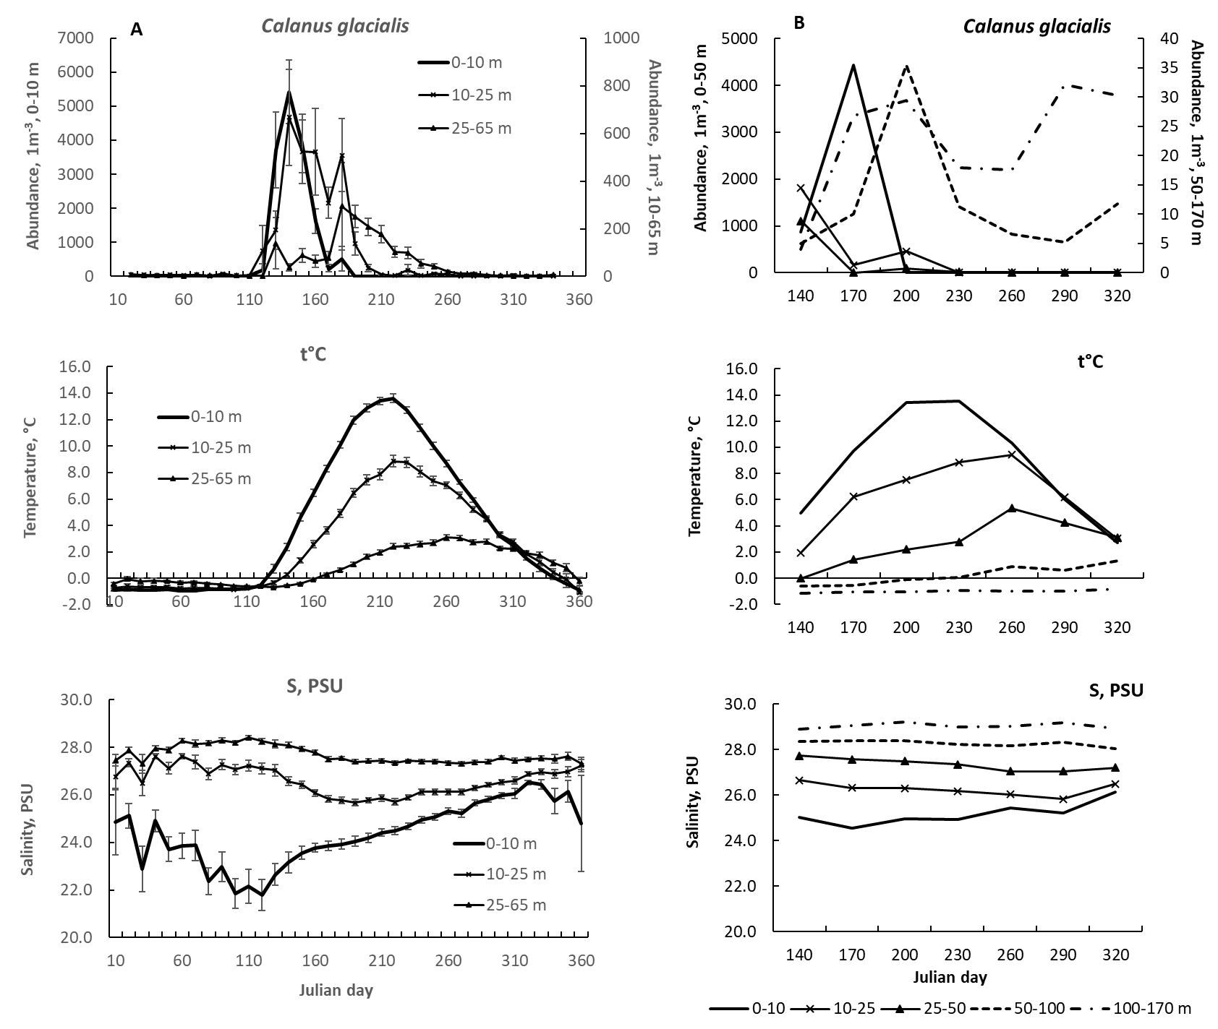
Fig. 1. Seasonal dynamics of Calanus glacialis abundance, water temperature and salinity at stations D-1 (panel A) and D-3 (panel B) in different layers of the water column. Vertical lines (A) indicate the standard errors of the mean; they are omitted for D-3 (B) due to relatively short observation period and, therefore, high variability.

The seasonal dynamics of seston organic C (particulate organic carbon, POC) was well-expressed in the productive upper 0—25-m water layer, the same for Chl a concentration (Fig. 2a). Two maxima were observed for Chl a concentration, in the end of May and through July. These maxima correlated with increased abundance of diatoms (Fig. 2b). Significant decline in diatom abundance occurred in the beginning of September. The POC dynamics was roughly comparable with Chl a dynamics, however, not necessarily, with one prolonged maximum through July and August (Fig. 2a).

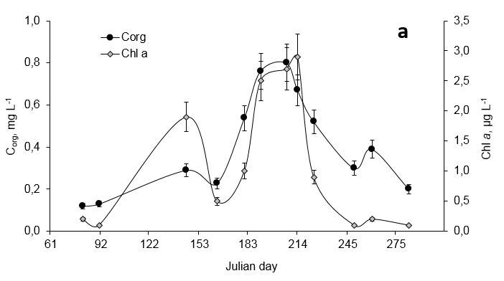

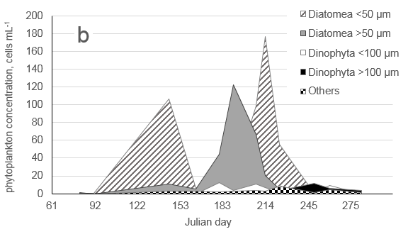
Fig. 2 Seasonal dynamics of major seston characteristics, station D-1 (2000—2008): (a) C_{org} and Chl a; (b) key phytoplankton taxa. !!! Картинки исправлены. 30 июля 2020

Seasonal dynamics of Calanus glacialis vertical distribution
Пока не стала ничего описывать, давайте приведём рис. 3 к финальной версии.
Обязательно отметить, что CIII есть и в September! – Сколько их?

ВАРИАНТ 1

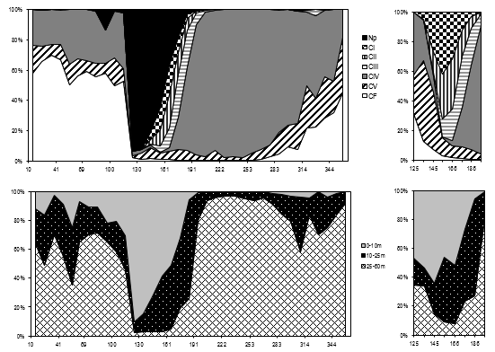
Fig. 3 Annual dynamics in vertical distribution of copepodite stages (a) and layers occupied (b) by Calanus glacialis on station D-1 (average for the period 1964—2017). Right insertion – except naupliar stages. Np – nauplii; CI-CV – immature copepodites; CF – females !!! Картинки исправлены. 30 июля 2020

КОЛЯ, ДАВАЙ ПОПРОБУЕМ СДЕЛАТЬ ТО ЖЕ САМОЕ ДЛЯ Д-3. МНЕ КАЖЕТСЯ, ЭТО САМЫЙ АДЕКВАТНЫЙ ВАРИАНТ ОТРАЖЕНИЯ НАШИХ ДАННЫХ – ВЫСЛАЛА ТЕБЕ ФАЙЛ С МОИМИ ИСХОДНИКАМИ, ЧТОБЫ ТЕБЕ НЕ МУЧАТЬСЯ С РИСОВАНИЕМ ГРАФИКОВ (НУЖНО ПРОСТО ПОДСТАВИТЬ ДАННЫЕ И РАСШИРИТЬ НА 5 СЛОЁВ – ОСТАВЬ ВРЕМЕННуЮ ШКАЛУ ТУ ЖЕ ДЛЯ СРАВНЕНИЯ)

ВАРИАНТ 2

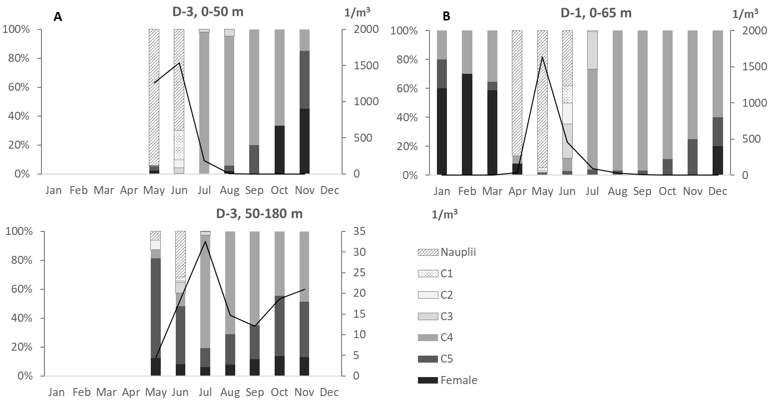

Рис. 3 Изменение состава популяции в течение года на глубоководной станции (А), на декадной станции (B). Сплошной линией обозначена суммарная плотность популяции. Левая ось ординат – доля конкретной стадии развития в популяции; правая – плотность популяции.

Multivariate analysis of Calanus glacialis seasonal cycle
The long-term observations at D-1 station considered the processes taking place in 0—65-m water layer (Table 1); however, a significant part of C. glacilais population in certain time periods tended to inhabit the water layers deeper than 50 m, as evidenced by the data from D-3 station (Fig. 3). Nevertheless, good correspondence of D-1 data with D-3 data (Fig. 4) allowed to use the dataset obtained at relatively shallow D-1 station for further multivariate analysis of C. glacialis seasonal cycle, since the observation period and sampling frequency exceeded greatly that at D-3 station (Table 1).

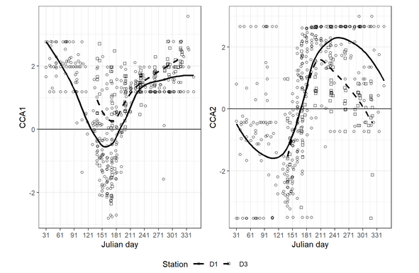

Fig. 4. Seasonal changes in CCA1 and CCA2 values at two sampling stations. Curves represent LOESS smoothers.

The resulting ordination allowed us to distinguish four combinations of conditions (depth, temperature, salinity, and Chl a concentration), referring for nauplii and certain copepodite stages (Fig. 5a, 5b):

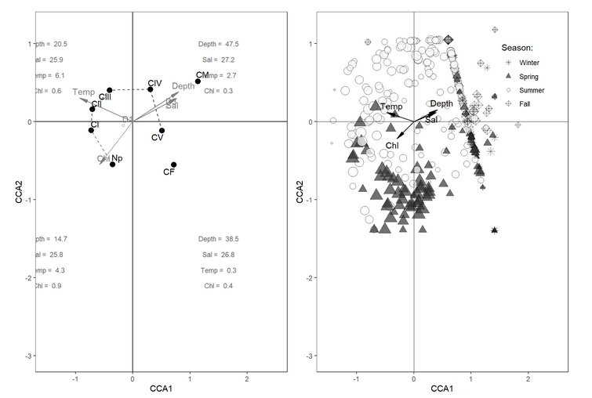
Fig. 5. Ordination of life cycle stages (left panel) and samples (right panel) in the space of constrained axes. The mean values of environmental parameters calculated for points located in each ordination quadrant are presented on the left panel; the size of points on the right panel is proportional to Calanus abundance (in each quadrant, mean values are correspondent).

  - I quadrant (CCA1 positive, CCA2 positive), characterized by relatively small depth of about 20 m, salinity of 26 psu, relatively high water temperature (5.3 °C), and Chl a concentration of about 0.6 μg L⁻¹, referring to CIII copepodite stage;
  - II quadrant (CCA1 positive, CCA2 negative), depths about 50 m, the highest salinity of 27.4 psu, low water temperature (below 2.0 °C), and the lowest Chl a concentration (less than 0.25 μg L⁻¹) , referring to CIV copepodite stage;
  - III quadrant (CCA1 negative, CCA2 negative), depths about 25—30 m, salinity 26.5 psu, the lowest temperature (0.8 °C), but relatively high Chl a concentration of about 0.5 μg L⁻¹, referring to CV and CF;
  - IV quadrant (CCA1 negative, CCA2 positive), depths about 10 m, lower salinity of 25 psu, but the highest temperature of 5.6 °C and the highest Chl a concentration exceeding 1.0 μg L⁻¹, referring to CI.
Nauplii and copepodite stages CII and CV referred to the transitional conditions between the corresponding quadrants (Fig. 5a).
These quadrants correspond to that at Fig. 5b, which describes the position of the Julian day of observation and population abundance in CCA plot. Briefly, the position of the sampling day relative to the beginning of the year may be calculated as

DayPosition = −cos(2π JulianDay 365)

This value is close to -1 when Julian day is close to January 1 (early January, late December) and is equal to 1 in late June—early July. The III and IV quadrants correspond to winter, so the I and II quadrants, to summer. At the same time, the highest abundance is observed in the area close to the II quadrant (the highest chlorophyll concentration).
The ordination of the stages of the life cycle is very naturally related to these conditions. The earliest stage (nauplii) are most abundant at the border of the II and III quadrants (Fig. 5a). They are associated with high chlorophyll concentration and are usual for low temperatures, corresponding for the period after ice melt in May (Fig. 3). The CI—CIII copepodites, apparently, grow and moult in warm water layer, relatively rich in food (Fig. 5a), corresponding to June and July (Fig. 3). As they grow to CIV, they descend to deeper water layers, which are poor in chlorophyll, but are cold and thus natural for this Arctic species. The CV and females are abundant at the boundary between the IV and III quadrants corresponding to the transition from deep-water lack of food to surface layer, still cold, but rich in food (early spring). The population inhabit on rich in chlorophyll and cold layer from 50 Julian day to 150 Julian day, corresponding to late February—late May (Fig. 5b).

Prosome dimensions
The cephalosome length in elder copepodites (CIV—CV) and females (CF) did not differ from February through July (Table 3). However, L_{c}/W ratio varied significantly in regard to the sampling depth, although no general pattern was observed. In February—April, CIV sampled in the upper layer (0—25 m) and below 25-m depth did not differ in L_{c}/W ratio. However, since early June through late July, the sub-populations (cohorts) in these water layers were different: more slender specimens (L_{c}/W > 4.5) inhabited the upper water layer, the specimens sampled below 25-m depth, were characterized by L_{c}/W < 4.4. Such a patter was a characteristic of CV already in late May and in the end of July. As observed for CIV, more "slender" CV copepodites inhabited the upper water layer. In females, such a difference has been recorded only once, in late May—early June.
Table 3. Cephalosome length and cephalosome length/width ratio (L_{c}/W) of Calanus glacialis in spring—summer period of 2005—2008, mean ± SD (Student t-test, p < 0.05 are highlighted in bold). Asterisks* indicate the data cited under Ashjian et al. 2003; n – number of studied specimens (similar for L_{c}/W ratio)
Period | Stage | Cephalosome length, mm |  |  |  |  | L_{c}/W ratio
Period | Stage | 0-25 m | n | 25-100 m | n | p | 0-25 m | 25-100 m | p
solid ice | CIV | 2.34 ± 0.19 | 14 | 2.39 ± 0.10 | 16 | 0.71 | 4.13 ± 0.28 | 4.38 ± 0.18 | 0.37
(February–March) | CF | 4.09 ± 0.09 | 11 | 4.00 ± 0.22 | 22 | 0.34 | 3.79 ± 0.17 | 3.79 ± 0.26 | 0.58
1–2 weeks before ice melt | CIV | 2.35 ± 0.14 | 10 | 2.33 ± 0.08 | 13 | 0.45 | 4.47 ± 0.21 | 4.69 ± 0.28 | 0.09
(April, 1–20) | CF | 4.09 ± 0.21 | 13 | 4.05 ± 0.13 | 41 | 0.11 | 3.74 ± 0.20 | 3.83 ± 0.21 | 0.84
4 weeks after ice melt | CV | 3.46 ± 0.20 | 51 | 3.43 ± 0.21 | 102 | 0.23 | 4.14 ± 0.03 | 4.03 ± 0.04 | < 0.01
(May, 20–June, 10) | CF | 4.10 ± 0.17 | 25 | 4.08 ± 0.18 | 68 | 0.47 | 4.54 ± 0.18 | 3.84 ± 0.03 | < 0.01
6 weeks after ice melt | CV | 3.43 ± 0.17 | 82 | 3.40 ± 0.19 | 57 | 0.14 | 3.83 ± 0.03 | 3.46 ± 0.04 | < 0.01
(June, 1–June, 20) | CF | 4.16 ± 0.12 | 21 | 4.07 ± 0.15 | 21 | 0.09 | 3.85 ± 0.14 | 3.72 ± 0.22 | 0.27
8 weeks after ice melt | CIV | 2.40 ± 0.11 | 60 | 2.41 ± 0.22 | 29 | 0.37 | 4.52 ± 0.02 | 4.30 ± 0.03 | < 0.01
(June, 10–June, 30) | CV | 3.36 ± 0.16 | 23 | 3.40 ± 0.18 | 146 | 0.15 | 3.96 ± 0.03 | 3.00 ± 0.37 | < 0.01
 | CF | 4.12 ± 0.13 | 14 | 4.11 ± 0.12 | 23 | 0.77 | 3.82 ± 0.15 | 3.71 ± 0.04 | 0.99
10–12 weeks after ice melt | CIV | 2.35 ± 0.10 | 186 | 2.38 ± 0.13 | 145 | 0.57 | 4.61 ± 0.02 | 4.40 ± 0.02 | < 0.01
(June, 20–July, 30) | CV | 3.46 ± 0.15 | 33 | 3.40 ± 0.17 | 239 | 0.49 | 4.08 ± 0.02 | 3.58 ± 0.04 | < 0.01
 | CF | 4.11 ± 0.10 | 12 | 4.08 ± 0.10 | 35 | 0.14 | 3.71 ± 0.09 | 3.83 ± 0.09 | 0.14
average (by layers) | CIV | 2.37 ± 0.14 | 270 | 2.39 ± 0.12 | 203 | 0.76 | 4.58 ± 0.03 | 4.40 ± 0.02 | < 0.01
 | CV | 3.43 ± 0.18 | 189 | 3.41 ± 0.19 | 544 | 0.63 | 4.07 ± 0.01 | 3.63 ± 0.08 | < 0.01
 | CF | 4.09 ± 0.17 | 96 | 4.07 ± 0.12 | 210 | 0.48 | 3.83 ± 0.48 | 3.80 ± 0.22 | 0.56
average  (pooled data  for 0—100 m) | CIV | 2.38 ± 0.13 | 473 | *2.36 ± 0.03 |  |  | 4.50 ± 0.29
average  (pooled data  for 0—100 m) | CV | 3.41 ± 0.18 | 733 | *3.21 ± 0.03 |  |  | 3.95 ± 0.49
average  (pooled data  for 0—100 m) | CF | 4.08 ± 0.15 | 306 | *3.87 ± 0.02 |  |  | 3.81 ± 0.31

Female gonad development in early spring
The females were clearly divided into two groups. First one, constituting about 70% of total population, was presented by brightly coloured ("red") animals, which had more developed gonads (G3—G4, on average) in the end of experiment than "pale" females (G2—G3) (ANOVA; F_{(1, 237)} = 19.99, p < 0.001). The 25-day starvation had no effect on coloration change (ANOVA; F_{(1, 237)} = 2.24, p = 0.14), as well as on L_{c} and L_{c}/W (ANOVA; F_{(1, 237)} = 2.414, p = 0.12); the last did not change also in starved/fed females (ANOVA; F_{(1, 237)} = 0.01, p = 0.92). In other words, females were characterized by constant cephalosome dimensions and colouration regardless the feeding conditions, i.e. in the beginning and in the end of each experiment.
In March—April 2008, Chl a concentration did not exceed 0.5 μg L⁻¹ (Fig. 2a), but the females produced from 2 to 18 pellets ind.⁻¹ day⁻¹, i.e. they were feeding quite actively at this food concentration. The gonad stage in the end of experiment depended on the food presence (ANOVA; F_{(1, 237)} = 7.05, p < 0.01), when the starved animals had significantly less developed gonads (G2—G3, on average) compared to the fed ones (G3—G5) (Fig. 6). However, no combined effect of animal coloration and food presence on the gonad was found (MANOVA; F_{(2, 235)} = 1.42, p = 0.24), i.e. both "red" and "pale" females had similar rates of gonad development under similar feeding conditions.
The starved animals hardly formed well-developed ovaries. However, the feeding on the natural phytoplankton during 25 days did not allow the fed females to start reproduction, and about 40% of them still had gonad stage G2. These females were mostly "pale" ones, constituting about 65% of all females of gonad stage G2. The "red" ones, which got the food supply, developed their gonads partially, about one third of their sampled population were still keeping stage G2, about 20% developed to stage G3, and about a half of them reached gonad stages G4 and G5. "Pale" females were quite inactive in gonad developing even at the food presence. Thus, about 50% of them were still at gonad stage G2, about 35% developed to stage G3, and only 15% of them reached gonad stages G4 and G5.

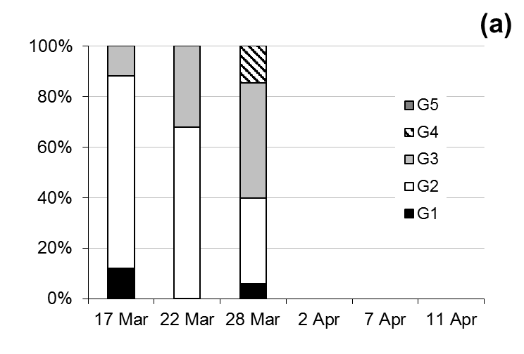 | 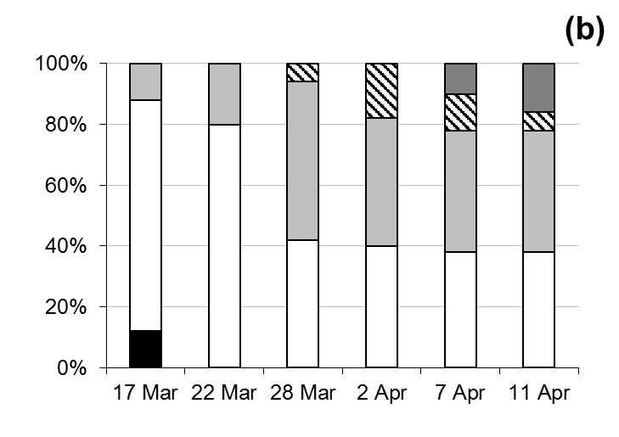
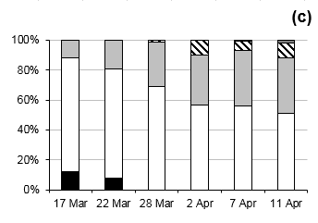 | Fig. 6 Female gonad stage dynamics in Calanus glacialis (station D-3, 2008) in early spring: (a) natural population (50—68 ind. per observation date); (b) fed females (natural phytoplankton, 50 specimens fed individually) ; (c) starved females, 202 ind., total. G1–G5 are gonad stages, accordingly to Table 2.  !!! Картинки исправлены. 30 июля 2020

Feeding
The food spectra of Calanus glacialis was studied in experiments and assessed by fatty acid (FA) analysis. The selectivity ratio, calculated for the most abundant phytoplankton taxa, revealed significant food preferences. In March, females preferred to consume small Pseudonitzschia (e = 0.82) and Chaetoceros (e = 0.61) species (cells less than 50 μm diameter), Thalassionema spp. (e = 0.76) and Thalassiosira spp. (e = 0.71), even when the total phytoplankton concentration was relatively low (Fig. 2b). In June, CIII and CIV copepodites were characterized by nearly the same food spectra, preferring Pseudonitzschia (e = 0.69) and Chaetoceros (e = 0.63) species (cells less than 100 μm diameter), Thalassionema spp. (e = 0.83), Leptocylindrus spp. (e = 0.70), and Tintinnidae (e = 0.92). The CV copepodites consumed the same species, but Leptocylindrus spp. was not a preferred genera (e = 0.02). In September, the studied developmental stages fed on small diatoms (cells less than 50 μm diameter, e = 0.72). Most of large thecate Dinophyta, especially Ceratium fusus, C. arcticum, and Protoperidinium spp., were totally avoided by all the copepodite stages (e = -1.00 for all species).
Marker FAs evidenced on relatively low herbivorous ratios, such as ΣPUFA, (n-3)/(n-6), UC and 16:1(n-7)/16:0, for elder copepodites (CIV—CV) and females in different seasons (Table 4). Surprisingly, high content of Dinophyta FA markers (DHA/EPA) was observed twice, for CV copepodites in July and September. Also, high content of SFA and extremely low UC index were found for nearly all the studied stages through the season, with minor exceptions (females, May).
The absolute daily ration varied greatly even within one developmental stage through the season, with the absolute maximum observed for females in May (Fig. 7a). Opposite to, CV tended to start active feeding much earlier, in March (Fig. 7b), feeding actively until October, but the ration decreased significantly in July and September. The CIV copepodites seemed to be the most active through the whole season, when both absolute and relative daily rations differed insignificantly (Fig. 7a, b). All the copepodites stopped feeding in late October. The contribution of algal C_{org} (recalculated by Chl a), may reach up to 99% in total consumed C_{org} in March and May, but was surprisingly low in July and September in all the studied stages varying from 35 to 50% (Fig. 7c).

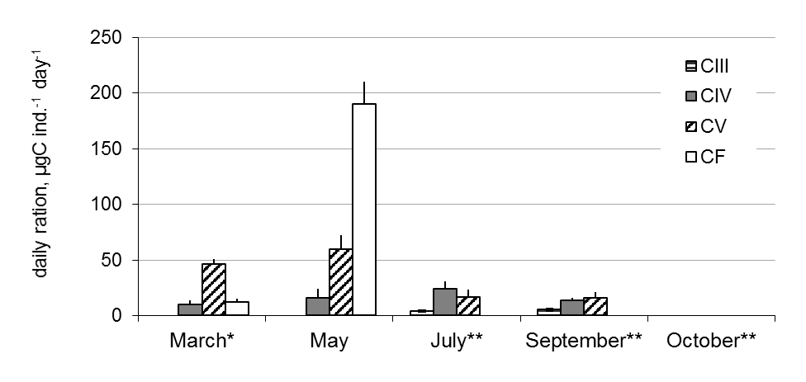 | 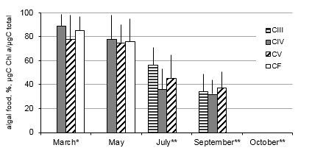
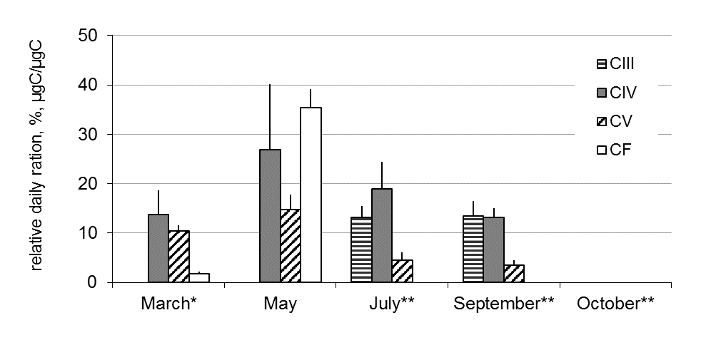 | Fig. 7 Seasonal feeding characteristics of Calanus glacialis in the White Sea: (a) absolute daily ration; (b) relative daily ration; (c) percent of algal food ingested, recalculated by impact of Chl a as C_{org} in total C_{org} consumed. One asterisk* -- ice algae were suggested as a food source; two asterisks** -- animals sampled in deep layers (25-100 m) were fed by the seston sampled in the surface water layer (0-5 m).  !!! Картинки исправлены. 30 июля 2020

Table 4. Fatty acids and major FA indices of Calanus glacialis in the White Sea. nd -- not detected; 0.0 < 0.05%.

Sampling depth | 0—25 m |  |  |  |  |  |  | 25 m—bottom
Season | March | May | May | July | Sept | Sept | Sept | March | March | May | July | Oct | Oct | Oct
Stage | CF | CIV | CF | CIV | CIV | CV | CF | CIV | CV | CV | CV | CIV | CV | CF
16:1(n-7) | 11.3 | 11.9 | 2.4 | 8.5 | 1.2 | 15.8 | 19.0 | 14.3 | 0.0 | 10.5 | 0.0 | 16.0 | 13.0 | 0.6
18:1(n-9) | 0.0 | 0.0 | 0.0 | 0.0 | 0.0 | 0.0 | 0.0 | 0.0 | 0.0 | 0.0 | 0.0 | 0.0 | 0.0 | 0.0
18:1(n-7) | 5.5 | 0.0 | 0.0 | 1.2 | 0.9 | 4.2 | 6.5 | 0.8 | 5.0 | 3.4 | 9.9 | 4.6 | 15.2 | 2.0
20:1(n-9) | 4.4 | 3.0 | 0.6 | 0.0 | 17.2 | 16.7 | 5.8 | 1.4 | 1.8 | 1.6 | 9.1 | 1.7 | 4.3 | 3.1
20:1(n-7) | 1.4 | 0.0 | 0.0 | 1.2 | 36.1 | 1.7 | 0.0 | 0.0 | 1.5 | 0.9 | 1.5 | 4.2 | 0.0 | 0.0
22:1(n-11) | 7.9 | 0.0 | 31.8 | 1.2 | 0.2 | 0.6 | 2.5 | 11.3 | 0.0 | 0.9 | 3.4 | 2.1 | 6.5 | 18.2
22:1(n-9) | 1.3 | 0.0 | 6.8 | 0.0 | 35.0 | 4.9 | 0.6 | 2.4 | 0.0 | 0.0 | 0.0 | 0.4 | 0.0 | 8.3
16:2(n-4) | nd | nd | nd | nd | nd | nd | nd | nd | nd | nd | nd | nd | nd | nd
16:4(n-1) | nd | nd | nd | nd | nd | nd | nd | nd | nd | nd | nd | nd | nd | nd
16:2(n-7) | nd | nd | nd | nd | nd | nd | nd | nd | nd | nd | nd | nd | nd | nd
18:4(n-3) | 0.0 | 0.0 | 0.0 | 0.0 | 0.0 | 0.0 | 0.0 | 0.0 | 0.0 | 0.0 | 2.3 | 1.3 | 0.0 | 0.0
20:5(n-3) | 1.5 | 3.0 | 11.6 | 0.0 | 0.0 | 0.6 | 0.9 | 7.5 | 1.6 | 0.8 | 1.9 | 3.8 | 4.3 | 12.1
22:6(n-3) | 0.0 | 0.0 | 23.3 | 3.7 | 0.0 | 5.9 | 1.5 | 0.0 | 0.0 | 2.8 | 17.5 | 5.0 | 4.3 | 0.0
ΣSFA | 52.5 | 46.3 | 9.6 | 69.5 | 2.6 | 30.0 | 36.5 | 35.7 | 50.2 | 65.7 | 53.2 | 34.0 | 34.8 | 15.5
ΣMUFA | 34.9 | 50.7 | 45.3 | 20.7 | 97.2 | 58.3 | 60.0 | 45.7 | 44.2 | 22.5 | 24.0 | 48.7 | 52.2 | 65.6
ΣPUFA | 12.6 | 3.0 | 45.1 | 9.8 | 0.2 | 11.7 | 3.5 | 18.6 | 5.6 | 11.7 | 22.8 | 17.2 | 13.0 | 18.9
(n-3)/(n-6) | 7.6 | 0.0 | 27.5 | 7.0 | 0.0 | 2.8 | 0.0 | 10.2 | 5.4 | 0.7 | 19.0 | 5.8 | 5.0 | 2.3
UC | 0.14 | 0.03 | 0.82 | 0.11 | 0.01 | 0.13 | 0.04 | 0.23 | 0.06 | 0.13 | 0.30 | 0.21 | 0.15 | 0.23
DHA/EPA | 0.0 | 0.0 | 2.0 | 0.0 | 0.0 | 10.7 | 1.8 | 0.0 | 0.0 | 3.5 | 9.2 | 1.3 | 1.0 | 0.0
16:1(n-7)/16:0 | 0.5 | 2.0 | 0.5 | 0.7 | 0.8 | 0.9 | 0.8 | 0.7 | 0.0 | 1.1 | 0.0 | 0.8 | 0.6 | 0.2
Total lipids, μg  (mean ± SD) | 166±34 | 10±3 | 85±23 | 20±5 | 30±9 | 100±16 | 275±65 | 50±12 | 120±43 | 80±17 | 70±17 | 60±11 | 165±30 | 280±66

Seasonal dynamics of organic compounds and lipids
Well-pronounced seasonal dynamics was observed for all the studied parameters: C_{org} content, C:N ratio, and lipid characteristics, such as total absolute and relative lipid content and relative content of lipid classes (Table 4; Fig. 8). The CIII copepodites in July and September were characterized by significantly different C:N ratio, 5.1±0.7 and 9.0±2.7, respectively, however, the body С_{org} was nearly the same, 30.3±1.6 in July and 39.3±8.4 in September (data not presented in Fig. 6 and Table 4). There were too few specimens for the lipid analysis; however, taking into account C:N ratio, one can conclude that lipid content has increased significantly by September.
In CIV, the lowest body C_{org} (Fig. 8a) and C:N ratio (Fig. 8b) were observed for specimens inhabiting the 0—25-m water layer in May. In March, the CIVs keeping below 25-m depth, were characterized by nearly the same body C_{org}, but higher C:N ratio, relative content of total lipids, as well as in the ratio of lipid classes (Fig. 8c, 8d); in particular, most lipids were TAG and WE (storage, >95%), but in May the pattern changed greatly, and about 65% of lipids were represented by structural phospholipids. In July, the pattern of lipid classes was similar to that observed in May, however, the body C_{org} was slightly higher. In September and October, the ratio of storage lipids changed greatly, when they comprised about 50% in early September and more than 90% in late October. The relative content of total lipids has also increased almost 1.5 times when comparing values observed in September and October, reflected as well in increasing C:N ratio. This evidenced on active lipid accumulation in autumn. The dynamics of absolute lipid content was well-pronounced, the lowest values were characteristic for CIV in May and July (on average, 10—20 μg ind.⁻¹), but in March, September, and October it was almost threefold higher, 30—60 μg ind.⁻¹ (Table 4). When considering all the biochemical parameters, the general pattern evidenced on significant storage of lipids from May through September, their transformation from TAG to WE before late October, and spending about a half of storage lipids through winter until May, although the absolute lipid content remained relatively high.
The CV copepodites in March, May, July, and September were characterized by nearly the same body C_{org} and relative lipid content (Fig. 8a, 8c). However, the ratio of lipid classes in July was significantly different, when most of them were storage (TAG and WE), as well as in October (Fig. 8d). This was true for the copepodites sampled below 25-m depth, but the dominance of structural lipids was the characteristics of the animals sampled in the upper 0—25-m water layer through the entire season, evidencing on active (non-dormancy) state of copepodites. Absolute lipid content was the lowest in May and July (ca. 70—80 μg ind.⁻¹), it increased up to ca. 100 μg ind.⁻¹ in September and reached the maximum (ca. 165 μg ind.⁻¹) in October; in March, the absolute lipid content was still high, ca. 120 μg ind.⁻¹ (Table 4). In general, this pattern resembled that observed for CIV copepodites, when the lowest lipid content and dominance of structural lipids was observed in late spring—summer (May—July), the highest lipid content and prevailing of storage lipids, in autumn and early spring, accompanied by pronounced changes in lipid class ratio.
Females of C. glacialis were characterized by pronounced dynamics of lipid content and ratio of lipid classes, supported by C:N ratio (Fig. 8b, 8c, 8d). In March, they were characterized by low C:N ratio, low relative lipid content, but high ratio of storage lipids. In May, the relative content of lipids was even lower, and structural lipids comprised more than 60% of total lipids comparing to about 20% in March (Fig. 8d). The pattern observed in September and October was similar to that in CV, but the share of TAG was higher in CF in September than in CV in October. The absolute lipid content also varied greatly, when the lowest values were observed in May (ca. 85 μg ind.⁻¹), the highest, in September and October (ca. 280 μg ind.⁻¹). By March, this parameter decreased by almost 50%, ca. 165 μg ind.⁻¹ (Table 4).
When considering these data in regard to the life cycle, the absolute lipid content in CV in October (25—100 m) was nearly the same to that in CF in March (0—25 m), and the ratio of storage lipids in CF was only slightly lower than in CV in October. This means that CF observed in the upper layer in March did not belong to the females molted from CV during winter using the lipids. Indirectly, these females may be attributed to "pale" ones that were forming their gonads less actively in the gonad development experiment (see above); unfortunately, the observations on female coloration were performed only during this experiment. These CF rather belonged to the group of females that entered the winter at CF stage, not at CV; they had already accumulated and transformed their lipids by September (Fig. 8d), in contrast to CIV and CV stages, which were still accumulating the lipids through September, feeding actively during this period (Fig. 7) and transformed them by late October. These females constituted up to 30% of the total CF cohort, so this could not be an exception, but a pattern. In May—July, the CIV—CF stages characterized by the lowest absolute and relative lipid content, accompanied by the lowest C:N and high share of structural lipids, may be considered as "freshly molted" from previous copepodites stages CIII—CV. In May, such CF may be attributed to reproducing females.

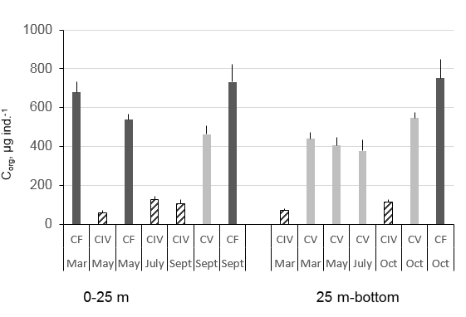 | 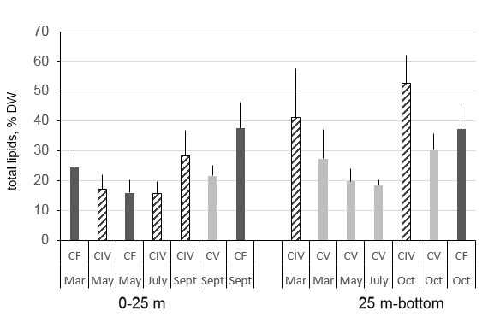
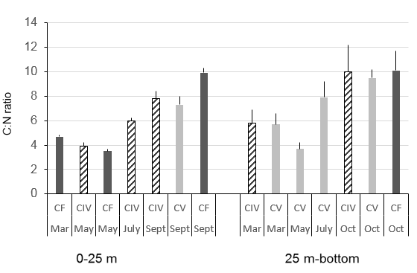 | 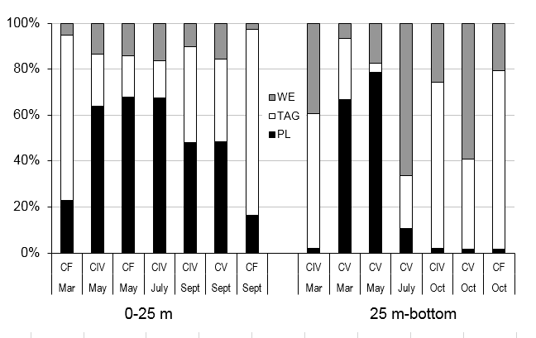
Fig. 8 Seasonal dynamics in organic C (a), C:N ratio (b), and lipid content (c, d) in elder copepodites (CIV-CV) and females (CF) of Calanus glacialis: WE – wax esters; TAG – triacylglycerols; PL – phospholipids; “0-25 m” and “25 m-bottom” are sampling layers. !!! Картинки исправлены. 30 июля 2020

DISCUSSION
General scheme of Calanus glacialis life cycle in the White Sea was suggested by Prygunkova (1968, 1974) and specified by Kosobokova (1998, 1999). Briefly, the reproduction takes place in May-June, when the females spawn in the upper water layer. Naupliar growth and molting up to CIV copepodite stage occur during the first summer. The CIV copepodites store the lipids and overwinter; next spring, they molt to CV, store the lipids and overwinter again, reaching mature stages without any food supply using the lipids. The females, which have no possibility to finish the reproduction successfully in the third spring of the life history, can resorb the lipids and overwinter once more. This scheme fits nicely the principal “Calanus” life cycle pattern (Slagstad and Tande 1990; Arnkværn et al. 2005; Falk-Petersen et al. 2009; Ji et al., 2012). Going deeper in details of species biology and ecology, some new insights have been found within our study that allowed to fill in the blanks explaining not only the grounds of C. glacialis life cycle strategy, but also a success of this species at the range margin. As no other Calanus species is reported for the study area (Choquet et al., 2018), this allows to attribute all the results to Calanus glacialis solely.
Unusual environment of the White Sea in regard to the general biology of the Arctic cold-water epipelagic copepod species naturally results in ordination of the stages of its life cycle and reflects the nature of ontogenetic vertical migrations through the water column. Nauplii are most abundant at high chlorophyll concentrations, when the water temperature is naturally low. The CI-CIII copepodites grow in relatively warm, but still food-rich water layer in May-June. As they grow, they migrate gradually to deeper layers, which are characterized by very low food concentration in terms of chlorophyll, but by optimal temperature range. Females and CVs face with the most favorable conditions in spring, when the upper water layer is still cold, but rich in phytoplankton, which is a source of essential polyunsaturated fatty acids (Checkley, 1980) necessary for successful egg forming and hatching (Martynova et al., unpublished). Nevertheless, it seems that for some reasons elder copepodites (CIV—CV) and females in different seasons do not get all the energy (lipid) reserves from the phytoplankton only, since marker FAs evidenced on relatively low herbivorous ratios, especially in July and September, when the ratio of Dinophyta FA markers was quite high. Meantime, this phytoplankton group was nearly absent in the Utermöhl countings, which testify for a high ratio of naked flagellate species in the diet. Relative predatory is evidenced by extremely low UC index for nearly all the studied stages through the season, with minor exceptions (females, May), as well as possible consuming of bacteria-rich particles, evidenced by high content of SFA (Levinsen e al. 2000; Stevens et al. 2004a, 2004c). In addition, when considering the average chlorophyll concentration in the study area, it seems to be relatively low in comparison to highly productive marginal ice zone, where Calanus species feed, reproduce, and grow in the Arctic Ocean (Hansen et al., 1996; Falk-Petersen et al., 1999; Pasternak et al., 2002). All these facts testify for prolonged period of feeding, starting as early as possible in spring and ending in September, since the copepodites have both to store necessary amount of lipids and to obtain sufficient supply of certain fatty acids.
Previously, there was no doubt that C. glacialis overwintered as CV (Prygunkova, 1974), but then CF was also considered as a possible overwintering stage (Kosobokova, 1999). However, molting to CIV stage coincides with significant increase of the water temperature in the upper productive layer. Meantime, CIV copepodites still need significant amount of food supply to store the lipids to overwinter. Feeding activity patterns and food spectra may prove such suggestion, when the feeding activity of CIV copepodites stays nearly the same from March through September, indicating high-energy demands both for CV molting and overwintering as CIV copepodites. The FA analysis reveals high relative amount of both bacterial and Dinophyta fatty acids, which may be consumed during second half of the summer period. The last is also supported by significantly low percentage of Chl a consumed after the spring period ends. Omnivory and even predatory is described for arctic Calanus species, C. glacialis and C. finmarchicus (Perueva 1977a; Nejstgaard et al. 1997; Levinsen e al. 2000; Sato et al. 2002; Stevens et al. 2004a, 2004c; Basedow and Tande 2006; Castellani et al. 2008), with high impact of algal diet in a spring bloom conditions (Smith and Lane 1988; Koski 2007; Saage et al. 2008; Søreide et al. 2008) and significant share of Dynophyta in the diet (Madsen et al. 2001; Turner et al. 2001). The dynamics of relative total lipid content as well as high amount of structural lipids in CIV through all the year also exhibit high activity of this copepodite stage, comparing to undoubtedly “normally” diapausing CV copepodites and females. Such activity of CIV copepodites lays out of the scheme described for the high Arctic, when the feeding stops after the spring bloom ends (Levinsen et al. 2000). All these facts allow us concluding quite unfavorable conditions especially for CIV and, possibly, for CIII, copepodites through the summer period, which are, nevertheless, compensated by high food plasticity. The daily feeding dynamics was observed in CIV copepodites of C. glacialis in the White Sea in late August also by Perueva (1977b, 1984) and in higher latitudes by Båmstedt (1984) and Cottier et al. (2006). High feeding plasticity of CIV copepodites of C. glacialis in the White Sea, when this species consumes dinoflagellates and even naupliar stages of copepods, was also described before (Perueva 1977a). Our data on experimentally obtained data on food spectra and marker FAs allow supposing that not only CIV, but also CV copepodites and females may consume non-algal food, when the algal resources are lacking, and thus complete the lipid storage successfully. Kosobokova (1990) supposed that energy accumulation in C. glacialis takes place in the spring and summer of the second year; however, we tend to prolong this period in the White Sea for at least until the end of September for CIV copepodites.
Temperature may largely alter body volume (e.g. width) rather than body length, and lipids may reflect more direct effects of food supply in Calanus species (Escribano and McLaren 1992). This is obvious when considering the total amount of lipids and the share of WE and TAG in CF and CIV—CV in September and October. Females sampled in September are “happy” with the amount of lipids, so they start to transform TAGs to WEs. The opposite pattern is observed for CIVs and CVs, which are still storing the lipids without pronounced transformation. Whe comparing the C:N ratio for these stages, it is clear that the lowest lipid content is a characteristics of copepodites in summer. Therefore, even at limited food resources in the deep water layers, they still “do their best” to store necessary lipid reserves. It seems discussible that CIV specimens, molted in the end of spring to CV, have a chance to store essential amount of lipids to perform winter molt to mature stage and start to form gonads, which is extremely expensive energy process (Sargent and Falk-Petersen 1988; Mayor et al. 2009). After CVs store essential amount of lipids they descend to deep layers (Kosobokova 1998, 1999; present study), as it is observed in the other Arctic areas (Basedow et al. 2004; Schmidt et al., 2018).
Prolonged molting period from CV to female (Kosobokova 1998, 1999) as well as possible food insufficiency during springtime, which appears as a result of short period of cold upper waters and vulnerability of CV copepodites and females to high temperature (present study), as well as original morphological and biochemical data lead us to conclude confidently on the second possible overwintering as a female stage in Calanus glacialis in the White Sea. Suggested first by Kosobokova (1998, 1999), this was significantly proved by two female cohorts observed in the early spring, which differed in cephalosome length/width ratio (L_{c}/W), specimen coloration and gonad development rates (present study). In particular, the females do not differ in absolute length, but in terms of the L_{c}/W ratio, and a month after the ice melts, there are relatively “elongated” (=freshly molted) females in the upper water layers, and those below 25-m depth look like “pre-winter” (“wide”) females. Therefore, it could be assumed that the females characterized by L_{c}/W ratio below 4.0 may molt in winter using the lipid reserves, but the others (elongated and freshly colored) rely much on food in spring for molting. Interestingly, the females of Calanus glacialis inhabiting the White Sea are significantly larger than those inhabiting the Canadian Arctic (Ashjian et al., 2003), but not the CV and CIV copepodites. By now, this issue remains open for future studies. In our opinion, the CV life stage duration and biology peculiarities of this developmental stage in the White Sea also differ from the “classical glacialis” model. It was proposed that CIV copepodites molted to CV and stored the lipids during the second spring/summer and molted to mature stages during second winter (Prygunkova 1974; Kosobokova 1998, 1999). The data on L_{c}/W ratio and lipid classes’ pattern in CV copepodites tend us to propose one more winter period for at least the part of CV population, since two distinct cohorts are observed through most of the year. This is supported by two cohorts differing in prosome characteristics as early as from CIV stage, persisting through CV and CF. In the study area, in early spring (March—April), Calanus glacialis females form two distinct cohorts; the specimens differ in coloration of genital pores, gut, and antennae, as well as by prosome morphometry and lipid status.
The other pending issue was the reasons of such “double” overwintering. As suggested above for CV copepodites, we assume these are the females molting the latest or being exposed to environmentally-driven food insufficiency. The gonad development process in females is highly food-dependent, evidence both by our study and by the number of earlier publications (Tande et al. 1985; Hirche and Bohrer 1987; Kosobokova and Hirche 2001; Hirche and Kwasniewski 1997). However, some authors argue for food-independent gonad maturation in C. glacialis (unpublished data by Conover & Harris in Conover 1988; Smith 1990; Hirche and Kattner 1993; Niehoff et al. 2002), as it is observed in C. hyperboreus (Pasternak et al. 2001; Falk-Petersen et al. 2009). Based on our data, we assume that both energy resources play significant role in C. glacialis population in the White Sea, when early gonad development may occur using the lipid storage, but females need the food supply essentially on the latest stages of egg forming and egg releasing to sustain the population, as it has been shown for Calanus species in the Arctic (Barthel 1990; Hirche 1989; Hirche et al. 1991; Richardson et al. 1999; Seuthe et al. 2007; Madsen et al. 2008). The dynamics of lipid classes and total lipid content as well as feeding activity in females exhibits strong seasonal changes. The females are supposed to be active in May and even in September in the upper water layers, while they are characterized by low proportion of phospholipids comparing to the storage lipids in October in deep layers. The female activity in May is understandable, since during this period the reproduction and active feeding take place in the upper water layers. High feeding activity through summer was observed for C. glacialis/marshallae in the Chukchi and Beaufort seas (Plourde et al. 2005). The inactivity of the females and CIV-CV copepodites in October has also no wonder, when the copepods are ready for winter and storage lipids play significant role (Hagen 1999; Hagen and Auel 2001; Scott et al. 2002). The most interesting data are obtained for September. Comparing the ratio of structural lipids between elder copepodite stages, CIV-CF, in the upper water layers, one can easily recognize the same pattern, when structural lipids play much role than storage lipids; the opposite pattern may be found for the copepods sampled in deep water layers in October. We assume September as a period of activity for those copepodites, which still have to store energy (lipids) before the winter comes.
The most amazing result was the finding of CIII copepodites in September, never described earlier for the White Sea during this season. This stage is presented by a very small number (less than 2%) comparing to the abundance of CIVs and CVs, constituting the bulk of the wintering pool. However, characterized by similar body C_{org} in July and in September, the copepodites differ significantly by the C:N ratio, which evidences on high lipid content in autumn. This is a clear evidence on possibility of overwintering of a small part of population of CIII stage, probably, due to late molting and food insufficiency during summer period, as observed for C. hyperboreus in the Greenland Sea (Hirche, 1997).
We propose that Calanus glacialis population inhabiting the White Sea employs complimentary biennial life cycle with possible prolongation up to three and even four years (Fig. 9). The reproduction occurs in May-June; and it takes about 8-10 weeks to reach CIV copepodite stage. The scarcity of food resources due to warming of the productive upper layers evolves wider temperature optima in CI-CIII copepodites. High food plasticity, e.g. omnivorous feeding, is usual for elder copepodite stages, CIV-CF, in the period of food insufficiency. CIII and CIV copepodites are characterized by high feeding rates in early and late summer to molt (CIII) and store significant amount of lipids (CIV) to winter successfully. The feeding activity of CIV copepodites stays high from March through September, as well as high relative amount of structural lipids, which allows us comparing this strategy with the patterns observed for some Antarctic species, which stays active during the austral winter (Kattner et al. 1994; Kattner and Hagen 1995; Albers et al. 1996; Atkinson 1998). The CV copepodites, which have a chance to molt in early spring from CIV and to store the lipids during spring phytoplankton bloom, which occurs in May-June, descend to deep water layers and molt to mature stages, females and males, during next winter on lipid resources (Daase et al., 2018). Those CV copepodites, which molt the latest, store the lipids and winter as the same developmental stage, getting the chance next spring. The lipid resources may support the early gonad development in females, but the last ones are highly food-dependent to form ripe gonads and to lay eggs successfully. Those females, which do not reproduce during first “female” spring, due to temperature increase (Kosobokova 1999; Niehoff and Hirche 2005) or food insufficiency, may resorb the gonads back to lipid drop and winter once more. By some features, found within our study, we tend to refer C. glacialis in the White Sea to belong to “hyperboreus” life cycle rather than to “glacialis” type. In the White Sea, C. glacialis employs similar mechanisms of coping with unfavorable environment, such as prolongation of the entire life cycle duration, as C. hyperboreus in high Arctic due to limited resources within short available productive period limited by rapid water temperature increase in late spring.
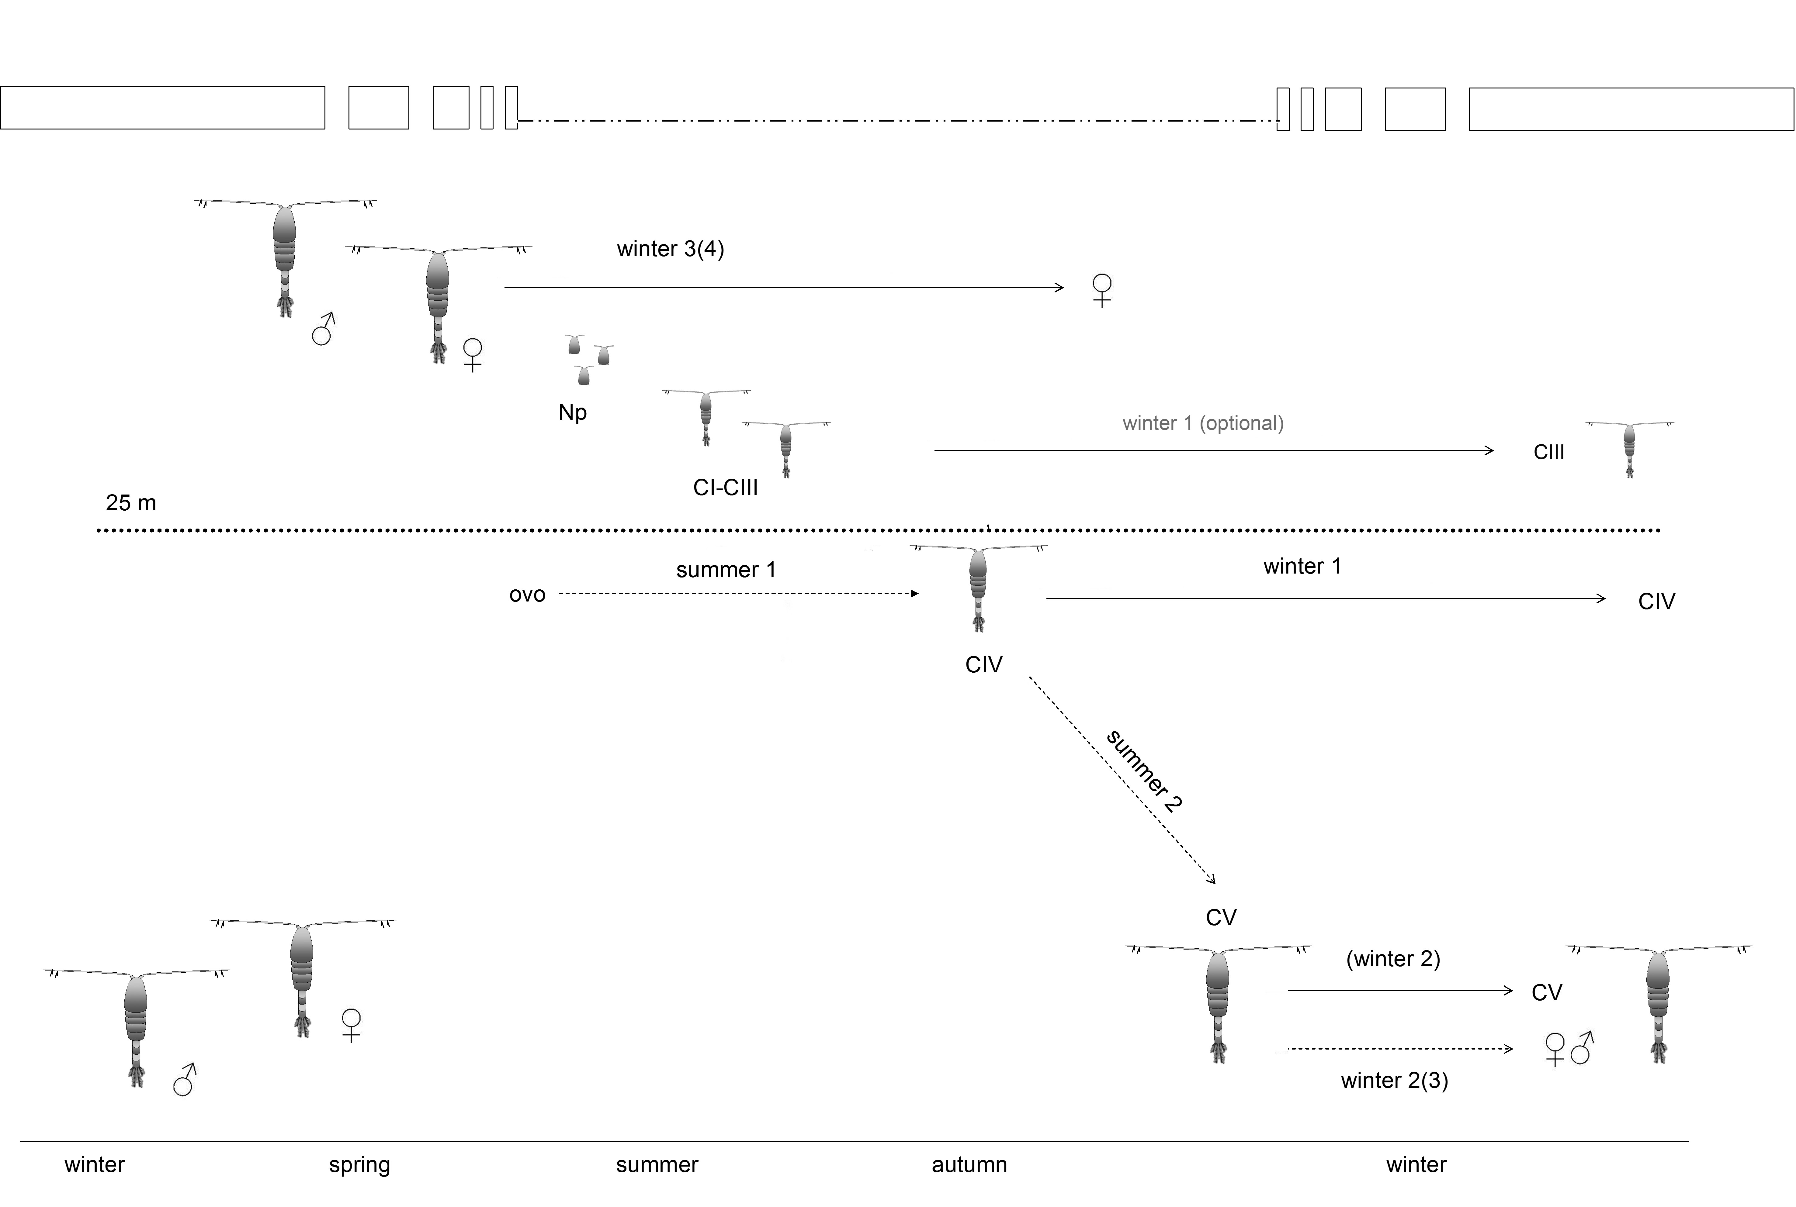
Fig. 9 Scheme of Calanus glacialis life cycle in the White Sea (compilation of original results and data by Prygunkova 1974; Kosobokova 1998, 1999). Np – naupliar stages; CI-CV – copepodite stages; dotted lines – molt periods; straight lines – wintering without molt; titles and numbers in the brackets indicate possible, but non-obligatory events. Note: the wintering of all diapausing copepodite stages takes place in the water layers below 25 m.

The adaptations of the life cycle of Calanus glacialis to relatively unfavourable conditions in the White Sea allow us assuming local ecotype of this species in the studied area. The population of C. glacialis in the White Sea is isolated from the other Arctic areas by the southern Barents Sea, where C. finmarchicus dominates (Pertzova and Pantyulin 2005). Being an isolated population for the last 5,000 years allows C. glacialis evolving special adaptations and peculiarities of the life cycle strategy in the White Sea, which allow this copepod species to cope with increasing water temperature (Usov et al., 2013) using the mechanisms developed naturally at the range margin. Calanus glacialis inhabiting the White Sea has evolved several specific mechanisms, which are very high feeding plasticity, elongated feeding period at relatively low food concentration, and prolongation of the life cycle similar to C. hyperboreus in the high Arctic. When considering possible effect of the global climate change (Beaugrand 2003; Carmack et al. 2006; Carmack and Wassmann 2006) in regard to the White Sea (Usov et al., 2013) and thus local C. glacialis population, we assume female reproduction period as the most vulnerable for the species success. The early ice melt in spring may lead to mismatch between the female readiness to start reproduction and spring phytoplankton bloom, reported for the other seas (Falk-Petersen et al 2007; Green and Pershing 2007). However, in the White Sea, C. glacialis may get second chance by the cohort of “secondly wintering” females, which may constitute up to 30% of female population. Wider temperature optima in CI-CIII copepodites and high feeding plasticity in elder copepodites may also impact positively to the species survival.

ACKNOWLEDGEMENTS
We are grateful to Prof. Ulrich Bathmann (AWI, IOW), Dr. Eva-Maria Noethig (AWI), Dr. Heidemarie Kassens (IFM-GEOMAR), and Dr. I. Primakov (ZIN RAS) for invaluable support; Christiane Lorenzen (AWI) and Sandra Murawski (AWI) for the help in sample processing, the staff of R/V “Kartesh”, R/V “Professor Vladimir Kuznetsov”, and inshore trawler “Belomor” for the assistance in sampling. Special thanks go to A.I. Babkov and R.V. Prygunkova, who performed the long-term observations on D-1 station from 1961 to 1990s.

FUNDING
The study was supported by EUR-OCEANS (Network of Excellence funded by the European Commission, contract no. 511106-2), Otto Schmidt Laboratory Fellowship (project OSL-07-11), and Russian Foundation for Basic Researches (RFBR projects nos. 08-04-01691-a and 08-04-98843-r_sever_a). The study is performed within the State Contract НАША НОВАЯ ТЕМА.

REFERENCES
Albers CS, Kattner G, Hagen W (1996) The composition of wax esters, tryacilglycerols and phospholipids in Arctic and Antarctic copepods: evidence of energetic adaptations. Marine Chemistry 55:347-358.
Arashkevich EG, Drits AV (1984) Experimental feeding in copepods Calanus helgolandicus and С. glacialis at various food concentrations. Oceanology 24:316-322. [In Russian with English abstract]
Arashkevich EG, Kosobokova KN (1988) To the problem of life-strategy of herbivorous copepods: Physiology and biochemical composition of the overwintering Calanus glacialis in starvation conditions. Oceanology 28:657-662. [In Russian with English abstract]
Arashkevich EG, Sergeeva OM (1991) Feeding rates of the White Sea copepod species Calanus glacialis on different phytoplankton species, its faecal pellet production rates and pellet sinking rates. In: Monitoring investigations of phytoplankton in the Baltic and other USSR seas. Gidrometeoizdat, Moscow, p. 285-294 [In Russian]
Arnkværn G, Daase M, Eiane K (2005) Dynamics of coexisting Calanus finmarchicus, Calanus glacialis and Calanus hyperboreus populations in a high-Arctic fjord. Polar Biology 28:528-538.
Ashjian CJ, Campbell RG, Welch HE, Butler M, Van Keuren D (2003) Annual cycle in abundance, distribution, and size in relation to hydrography of important copepod species in the Western Arctic Ocean. Deep-Sea Res I 50:1235-1261.
Atkinson A (1998) Life cycle strategies of epipelagic copepods in the Southern Ocean. J Mar Sys 15:289-311.
Auel H, Hagen W (2002) Mesozooplankton community structure, abundance and biomass in the Central Arctic ocean. Marine Biology 140:1013-1021.
Barthel KG (1990) Relationships of food uptake and body components of Calanus finmarchicus, C. glacialis and C. hyperboreus to particulate matter and water characteristics in Fram Strait. Polar Biol 10:343-350.
Basedow SL, Eiane K, Tverberg V, Spindler M (2004) Advection of zooplankton in an Arctic fjord (Kongsfjorden, Svalbard). Estuar Coast Shelf Sci 60:113-124.
Basedow S, Tande K (2006) Cannibalism by female Calanus finmarchicus on naupliar stages. Mar Ecol Progr Ser 327:237-245.
Bathmann U, Liebezeit G (1986) Chlorophyll in copepod faecal pellets: changes in pellet numbers and pigment content during a declining Baltic spring bloom. Marine Ecology - Pub Staz Zool Napoli I 7:59-73.
Båmstedt U (1984) Diel variations in the nutritional physiology of Calanus glacialis from Lat. 78°N in the summer. Mar Biol 79:257-267.
Beaugrand G, Reid PC, Ibanez F, Lindley JA, Edwards M (2002) Reorganization of North Atlantic marine copepod biodiversity and climate. Science 296:1692-1694.
Beaugrand G (2003) Long-term changes in copepod abundance and diversity in the north-east Atlantic in relation to fluctuations in the hydroclimatic environment. Fisheries Oceanography 12 (4-5) 270–283
Berger V, Dahle S, Galaktionov K, Kosobokova X, Naumov A, Rat'kova T, Savinov V, Savinova T (2001) White Sea. Ecology and Environment. Derzavets Publisher, St.Petersburg-Tromsø.
Berger VJa, Naumov AD, Usov N, Zubaha M, Smolyar I, Tatusko R, Levitus S (2003) 36-year time series (1963-1998) of zooplankton, salinity and temperature in the White Sea. NOAA Atlas NESDIS, 57.
Berger VJa (2007) Production potential of the White Sea. Exploration of Fauna of the Seas. Russian Academy of Sciences, St.Petersburg. [In Russian]
Blachowiak-Samolyk K, Kwasniewski S, Hop H, Falk-Petersen S (2008) Magnitude of mesozooplankton variability: a case study from the Marginal Ice Zone of the Barents Sea in spring. J Plank Res 30(3):311-323.
Calbet A, Saiz E, Alcaraz M (2002) Copepod egg production in the NW Mediterranean: effects of winter environmental conditions. Mar Ecol Prog Ser 237:173–184.
Carmack E, Barber D, Christensen J, Macdonald R, Rudels B, Sakshaug E (2006) Climate variability and physical forcing of the food webs and the carbon budget on panarctic shelves. Progress in Oceanography 71 (1) 145–181
Carmack E, Wassmann P (2006) Food webs and physical-biological coupling on Pan-Arctic shelves: unifying concepts and comprehensive perspectives. Progress in Oceanography 71:446-477.
Castellani C, Irigoien X, Mayor DJ, Harris RP, Wilson D (2008) Feeding of Calanus finmarchicus and Oithona similis on the microplankton assemblage in the Irminger Sea, North Atlantic. J Plankt Res 30(10):1095-1116.
Checkley D.M.D. The egg production of a marine planktonic copepod in relation to its food supply: Laboratory studies. Limnol. Oceanogr. 1980;25:430–446. doi: 10.4319/lo.1980.25.3.0430.
Chesson J (1983) The estimation and analysis of preference and its relationship to foraging models. Ecology 64:1297-1304.
Coachman LK, Aagaard K (1974) Physical Oceanography of Arctic and Subarctic Seas, Springer, New York.
Conover RJ (1988) Comparative life histories in the genera Calanus and Neocalanus in high latitudes of the northern hemisphere. Hydrobiologia 167/168:127-142.
Conover RJ, Huntley M (1991) Copepods in ice-covered seas - distribution adaptations to seasonally limited food metabolism growth patterns and life cycle strategies in polar seas. Journal of Marine Systems 2:1-41.
Cottier FR, Tarling GA, Wold A, Falk-Petersen S (2006) Unsynchronized and synchronized vertical migration of zooplankton in a high Arctic fjord. Limnol Oceanogr 51:2586-2599.
Daase M, Vik JO, Bagøien E, Stenseth NC, Eiane K (2007) The influence of advection on Calanus near Svalbard: statistical relations between salinity, temperature and copepod abundance. J Plankt Res 29
Daase et al., 2018 (New insights into the biology of Calanus spp.(Copepoda) males in the Arctic)
Daly KL (1997) Flux of particulate matter through the copepods in the Northeast Water Polynya. J Mar Sys 10:319-342.
Eilertsen HC, Tande K, Taasen JP (1989) Vertical distribution of primary production and grazing by Calanus glacialis Jashnov and C. hyperboreus Kroyer in Arctic waters (Barents Sea). Polar Biology 9:253-260.
Escribano R, McLaren IA (1992) Influence of food and temperature on lengths and weights of two marine copepods. J Exp Mar Biol Ecol 159:77-88.
Evans CA, O'Reilly JE, Thomas JP (1987) A Handbook for the measurement of chlorophyll a and primary production. Biological Investigations of Marine Antarctic Systems and Stocks (BIOMASS). Texas A&M University, College Station, Texas, USA.
Falk-Petersen S, Sargent JR, Tande K (1987) Lipid composition of zooplankton in relation to the Sub-Arctic food web. Polar Biology 8:115-120.
Falk-Petersen S, Pedersen G, Kwasniewski S, Hegseth E, Hop H (1999) Spatial distribution and life-cycle timing of zooplankton in the marginal ice zone of the Barents Sea during the summer melt season in 1995. Journal of Plankton Research. 21. 1249-1264. 10.1093/plankt/21.7.1249.
Falk-Petersen S, Timofeev S, Pavlov V, Sargent JR (2007) Climate variability and possible effects on arctic food chains: The role of Calanus. Pages 147-166 in: Ørbæk, J.B., Tombre, T., Kallenborn, R., Hegseth, E., Falk-Petersen, S. and Hoel, A.H. (Eds.), Arctic Alpine Ecosystems and People in a Changing Environment, Springer Verlag, Berlin. 433 p.
Falk-Petersen S, Mayzaud P, Kattner G, Sargent JR (2009) Lipids and life strategy of Arctic Calanus. Marine Biology Research 5(1):18-39.
Folch J, Lees M, Sloane-Stanley SH (1957) A simple method for isolating total lipids from animal tissues. J Biol Chem 226:497–509.
Frost BW (1972) Effect of size and concentration of food on the feeding behavior of marine planktonic copepod Calanus pacificus. Limnol Oceanogr 17:805-816.
Greene CH, Pershing AJ (2007) Climate drives sea change. Science 315:1084-1085.
Graeve M, Hagen W, Kattner G (1994a) Herbivorous or omnivorous? On the significance of lipid compositions as trophic markers in Antarctic copepods. Deep Sea Res I 41:915-924.
Graeve M, Hagen W, Kattner G (1994b) Diet-induced changes in the fatty acids composition of Arctic herbivorous copepods: experimental evidence of trophic markers. J Exp Mar Biol Ecol 182: 97-110.
Hagen W (1999) Reproductive strategies and energetic adaptations of polar zooplankton. Invertebrate Reproduction & Development 36:25-34.
Hagen W, Auel H (2001) Seasonal adaptations and the role of lipids in oceanic zooplankton. Zoology-Analysis of Complex Systems. 104(3-4):313-326.
Hansen, B., Christiansen, S. & Pedersen, G. Plankton dynamics in the marginal ice zone of the central Barents Sea during spring: carbon flow and structure of the grazer food chain. Polar Biol 16, 115–128 (1996). https://doi.org/10.1007/BF02390432
Hansen AS, Nielsen TG, Levinsen H, Madsen SD, Thingstad TF, Hansen BW (2003) Impact of changing ice cover on pelagic productivity and food web structure in Disko Bay, West Greenland: a dynamic model approach // Deep Sea Research Part I: Oceanographic Research Papers, 50 (1) 171-187
Harris RP, Lenz J, Wiebe PH, Huntley ME, Skjoldal HR (2000) Zooplankton Methodological Manual. Academic Press, NY.
Head EJH, Harris LR, Yashayaev I (2003) Distributions of Calanus spp. and other mesozooplankton in the Labrador Sea in relation to hydrography in spring and summer (1995-2000). Progr Oceanogr 59:1-30.
Heath MR, Robertson W, Gurney WSC, Mardaljevic J (1997) Modelling the population dynamics of Calanus in the Fair Isle Current off Northern Scotland. Journal of Sea Research 38:381-412.
Hirche H-J (1987) Temperature and plankton. II. Effect on respiration and swimming activity in copepods from the Greenland Sea. Mar Biol 94:347-356.
Hirche H-J (1997) Life cycle of the copepod Calanus hyperboreus in the Greenland Sea. Mar Biol 128(4):607-618. DOI: 10.1007/s002270050127
Hirche H-J, Bohrer RN (1987) Reproduction of the Arctic copepod Calanus glacialis in Fram Strait. Mar Biol 94:11-17.
Hirche HJ (1989) Egg production of the Arctic copepod Calanus glacialis: laboratory experiments. Mar Biol 103:311-318.
Hirche H-J, Baumann MEM, Kattner G, Gradinger R (1991) Plankton distribution and the impact of copepod grazing on primary production in Fram Strait, Greenland Sea. J Mar Sys 2: 477-494.
Hirche H-J, Kattner G (1993) Egg production and lipid content of Calanus glacialis in spring: indication of a food-dependent and food-independent reproductive mode. Mar Biol 117:615-622.
Hirche HJ, Hagen W, Mumm N, Ritcher C (1994) The Northeast Water Polynya, Greenland Sea. III. Meso- and macrozooplankton distribution and production of dominant herbivorous copepods during spring. Polar Biol 14:491-503.
Hirche H-J, Kwasniewski S (1997) Distribution, reproduction and development of Calanus species in the Northeast Water in relation to environmental conditions. J Mar Sys 10:299-317.
Huntley M.E. (1988) Feeding biology of Calanus: a new perspective. Hydrobiologia 167/168:83-99.
Huntley M, Strong KW, Dengler AT (1983) Dynamics and community structure of zooplankton in the Davis Strait and Northern Labrador Sea. Arctic 36:143-161.
IPCC Report (2007) Intergovernmental Panel on Climate Change. Climate Change 2007: The Physical Science Basis (Summary for Policymakers). http://www.ipcc.ch
Ji R., Ashjian C.J., Campbell R.G., Chen C., Gao G., Davis C.S., Cowles G.W., Beardsley R.C. (2012) Life history and biogeography of Calanus copepods in the Arctic Ocean: An individual-based modeling study. Progress in Oceanography 96(1):40-56. https://doi.org/10.1016/j.pocean.2011.10.001.
Juul-Pedersen T, Nielsen TG, Michel C, Møller EF, Tiselius P, Thor P, Olesen M, Selander E, Gooding S (2006) Sedimentation following the spring bloom in Disko Bay, West Greenland, with special emphasis on the role of copepods. Mar Ecol Progr Ser 314: 239–255.
Kaartvedt, S. (2008) Photoperiod may constrain the effect of global warming in arctic marine systems. J Plank Res 30:1203-1206.
Kattner G, Fricke HSG (1986) Simple gas-liquid chromatographic method for the simultaneous determination of fatty acids and alcohols in wax esters of marine organisms. Journal of Chromatography 361:263-268.
Kattner G, Graeve M, Hagen W (1994) Ontogenetic and seasonal changes in fatty acid/alcohol compositions of the dominant Antarctic copepod Calanus propinquus, Calanoides acutus and Rhincalanus gigas. Marine Biology 118: 637-644.
Kattner G, Hagen W (1995) Polar herbivorous copepods - different pathways in lipid biosynthesis. ICES J Marine Sci 52:329-335.
Koski M (2007) High reproduction of Calanus finmarchicus during a diatom-dominated spring bloom. Mar Biol 151:1785-1798. DOI 10.1007/s00227-007-0615-2
Kosobokova KN (1990) Age-related and seasonal changes in the biochemical makeup of the copepod Calanus glacialis Jaschnov as related to the characteristics of its life cycle in the White Sea. Oceanology 30:103-109. [In Russian with English abstract]
Kosobokova KN (1993) Reproduction and egg production of the White Sea copepod Calanus glacialis under experimental conditions. Oceanology 33:337-340. [In Russian with English abstract]
Kosobokova KN (1998) New data on the life cycle of Calanus glacialis in the White Sea (based on seasonal observations of its genital system development). Oceanology 38(3):347-355. [In Russian with English abstract]
Kosobokova KN (1999) The reproductive cycle and life history of the arctic copepod Calanus glacialis in the White Sea. Polar Biology 22:254-263.
Kosobokova KN, Hirche HJ (2001) Reproduction of Calanus glacialis in the Laptev Sea, Arctic Ocean. Polar Biology 24:33-43.
Levinsen H, Turner JT, Nielsen TG, Hansen BW (2000) On the trophic coupling between protists and copepods in arctic marine ecosystems. Mar Ecol Progr Ser 204:65-77.
Madsen SD, Nielsen TG, Hansen BW (2001) Annual population development and production by Calanus finmarchicus, C. glacialis and C. hyperboreus in Disco Bay, Western Greenland. Mar Biol 139:75-93.
Madsen SD, Nielsen TG, Tervo OM, Söderkvist J (2008) Importance of feeding for egg production in Calanus finmarchicus and C. glacialis during the Arctic spring. Mar Ecol Progr Ser 252:177-190. doi: 10.3354/meps07129
Manly BFJ, Miller P, Cook LM (1972) Analysis of a selective predation experiment. American Naturalist 106:719-736.
Mayor DJ, Anderson TR, Pond DW, Irigoien X (2009) Egg production and associated losses of carbon, nitrogen and fatty acids from maternal biomass in Calanus finmarchicus before the spring bloom. J Mar Sys 78(4):505-510.
Nejstgaard J, Gismervik I, Solberg PT (1997) Feeding and reproduction by Calanus finmarchicus, and microzooplankton grazing during mesocosm blooms of diatoms and the coccolithophore Emiliania huxleyi. Mar Ecol Progr Ser 147:197-217.
Niehoff B (1998) The gonad morphology and maturation in Arctic Calanus species. J Mar Sys 15:53-59.
Niehoff B, Madsen SD, Hansen BW, Nielsen TG (2002) Reproductive cycles of three dominant Calanus species in Disko Bay, West Greenland. Marine Biology 140:567-576.
Niehoff B, Hirche H-J (2005) Reproduction of Calanus glacialis in the Lurefjord (western Norway): indication for temperature-induced female dormancy. Mar Ecol Progr Ser 285:107-115.
Niehoff B (2007) Life history strategies in zooplankton communities: The significance of female gonad morphology and maturation types for the reproductive biology of marine calanoid copepods. Progr Ocean 74:1-47.
Olli K, Wassmann P, Reigstad M, Ratkova TN, Arashkevich E, Pasternak A, Matrai PA, Knulst J, Tranvik L, Klais R, Jacobsen A (2007) The fate of production in the Central Arctic Ocean - Top-Down regulation by zooplankton expatriates? Progr Oceanogr 72:84-113.
Pasternak A, Arashkevich E, Tande K, Falkenhaug T (2001) Seasonal changes in feeding, gonad development and lipid stores in Calanus finmarchicus and C. hyperboreus from Malangen, northern Norway. Mar Biol 138:1141-1152.
Pasternak A, Riser CW, Arashkevich E, Rat'kova T, Wassmann P (2002) Calanus spp. grazing affects egg production and vertical carbon flux (the marginal ice zone and open Barents Sea). Journal of Marine Systems, Volume 38, Issues 1–2, Pages 147-164, https://doi.org/10.1016/S0924-7963(02)00174-4.
Pertsova NM, Pantyulin AN (2005) Interrelationships between copepods (Copepoda, Calanoida) of the White and Barents seas and mechanisms of the independence of the White Sea population. Zoologichesky Zhurnal 84:948-956.
Perueva EG (1977a) Some experimental information on the feeding of IV copepodite stage of Calanus glacialis Jashnov. Qualitative composition of food. Oceanology 17:890-895. [In Russian with English abstract]
Perueva EG (1977b) The diurnal feeding rhythm of IV copepodite stage of Calanus glacialis Jashnov. Oceanology 17:1085-1089. [In Russian with English abstract]
Perueva EG (1984) On feeding of IV copepodite stage of Calanus glacialis from the Kandalaksha Bay of the White Sea. Quantitative characteristics of feeding. Oceanology 24:323-328. [In Russian with English abstract]
Plourde S, Campbell RG, Ashjian CJ, Stockwell DA (2005) Seasonal and regional patterns in egg production of Calanus glacialis/marshallae in the Chukchi and Beaufort seas during spring and summer, 2002. Deep-Sea Res II 52:3411-3426.
Prygunkova RV (1968) On the cycle of development of Calanus (Calanus glacialis Jaschnov) in the White Sea. Doklady Akademii nauk USSR 182:1447-1450. [in Russian]
Prygunkova RV (1974) Some features of zooplankton seasonal changes in Chupa Inlet, the White Sea (Nekotorye osobennosti sezonnogo razvitiya zooplanktona guby Chupa Belogo morya). Seasonal changes in the White and Barents Seas (Sezonnye yavleniya v zhizni Belogo i Barentseva morey). Leningrad, pp 4-55. [In Russian]
Richardson K, Jonasdottir S, Hay SJ, Christoffersen A (1999) Calanus finmarchicus egg production and food availability in the Faroe-Shetland Channel and northern North Sea: October-March. Fish Oceanogr 8(S1):153-162.
Riser CW, Reigstad M, Wassman P, Arashkevich E, Falk-Petersen S (2007) Export or retention? Copepod abundance, faecal pellet production and vertical flux in the marginal ice zone through snap shots from the northern Barents Sea. Polar Biol. PAGES doi 10.1007/s00300-006-0229-z
Saage A, Altin D, Vadstein O, Sommer U (2008) Trophic position of Calanus finmarchicus (Copepoda, Calanoida) in the Trondheim Fjord. J Sea Res 59: 162–172.
Safronov SG (1984) Ecology of the copepod Calanus glacialis from the Sea of Okhotsk (in Russian). Sov J Mar Biol 10:200-203.
Sargent JR, Falk-Petersen S (1988) The lipid biochemistry of calanoid copepods. Hydrobiologia 167/168:101-114.
Sato M, Sasaki H, Fukuchi M (2002) Stable isotopic compositions of overwintering copepods in the Arctic and Subarctic waters and implications to the feeding history. J Mar Sys 38:165-174.
Schwamborn R, Bonecker SLC, Galvao IB, Silva TA, Neumann-Leitao S (2004) Mesozooplankton grazing under conditions of extreme eutrophication in Guanabara Bay, Brazil. J Plankt Res 26:983-992.
Schwamborn R, Ekau W, Silva AP, Schwamborn SHL, Silva TA, Neumann-Leitao S, Saint-Paul U (2006) Ingestion of large centric diatoms, mangrove detritus, and zooplankton by zoeae of Aratus pisonii (Crustacea: Brachyura: Grapsidae). Hydrobiologia 560:1-13.
Scott CL, Kwasniewski S, Falk-Petersen S, Sargent JR (2000) Lipids and life strategies of Calanus finmarchicus, Calanus glacialis and Calanus hyperboreus in late autumn, Kongsfjorden, Svalbard. Polar Biology 23:510-516.
Seuthe L, Darnis G, Riser CW, Wassmann P, Fortier L (2007) Winter-spring feeding and metabolism of Arctic copepods: insights from faecal pellet production and respiration measurements in the Southeastern Beaufort Sea. Polar Biology 30:427-436.
Slagstad D, Tande KS (1990) Growth and production dynamics of Calanus glacialis in an arctic pelagic food web. Mar Ecol Progr Ser 63: 189-199.
Schmidt et al., 2018 (Lipid load triggers migration to diapause in Arctic Calanus copepods—insights from underwater imaging)
Smith SL, Lane PVZ (1988) Grazing of the spring diatom bloom in the New York Bight by the calanoid copepods Calanus finmarchicus, Metridia lucens and Centropages typicus. Cont Shelf Res 8(5-7):485-509.
Smith SL (1990) Egg production and feeding by copepods prior to the spring bloom of phytoplankton in Fram Strait, Greenland Sea. Mar Biol 106:59-69.
Søreide JE, Falk-Petersen S, Hegseth EN, Hop H, Carroll ML, Hobson KA, Blachowiak-Samolyk K (2008) Seasonal feeding strategies of Calanus in the high-Arctic Svalbard region. Deep-Sea Res II 55: 2225– 2244.
Stevens CJ, Deibel D, Parrish CC (2004a) Copepod omnivory in the North Water Polynya (Baffin Bay) during autumn: spatial patterns in lipid composition. Deep-Sea Res Part I 51:1637-1658.
Stevens CJ, Deibel D, Parrish CC (2004b) Incorporation of bacterial fatty acids and changes in a wax ester-based omnivory index during a long-term incubation experiment with Calanus glacialis Jaschnov. J Exp Mar Biol Ecol 303:135-156.
Stevens CJ, Deibel D, Parrish CC (2004c) Species-specific differences in lipid composition and omnivory indices in Arctic copepods collected in deep water during autumn (North Water Polynya). Marine Biology 144: 905-915.
Tackx MLM, van de Vrie EM (1985) Calculations of results in grazing experiments using the counting method. Hydrobiological Bulletin 19:29-36.
Tamelander T, Renaud PE, Hop H, Carroll ML, Ambrose Jr WG, Hobson KA (2006) Trophic relationships and pelagic-benthic coupling during summer in the Barents sea Marginal Ice Zone, revealed by stable carbon and nitrogen isotope measurements. Mar Ecol Progr Ser 310:33-46.
Tande K (1988) The effects of temperature on metabolic rates of different life stages of Calanus glacialis in the Barents Sea. Polar Biol 8:457-461.
Tande K, Henderson RJ (1988) Lipid composition of copepodite stages and adult females of Calanus glacialis in Arctic waters of the Barents Sea. Polar Biology 8:333-339.
Tande KS, Hassel A, Slagstad D (1985) Gonad maturation and possible life cycle strategies in Calanus finmarchicus and Calanus glacialis in the northwestern part of the Barents Sea. In: Gray JS, Christiansen ME (eds) Marine biology of polar regions and effects of stress on marine organisms. Wiley, Chichester, pp 141-155.
Thibault D, Head EJH, Wheeler PA (1999) Mesozooplankton in the Arctic Ocean in summer. Deep-Sea Res I 46:1391-1415.
Tsyban AV (Ed.) (1980) Handbook on methods of biological analysis of the marine water and sediments. Leningrad, Gidrometeoizdat. [In Rissian].
Turner JT, Levinsen H, Nielsen TG, Hansen BW (2001) Zooplankton feeding ecology: grazing on phytoplankton and predation on protozoans by copepod and barnacle nauplii in Disko Bay, West Greenland. Mar Ecol Progr Ser 221:209-219.
Usov NV, Zubakha MA (2004) Temperature optimums of the White Sea zooplankton. Biologya morya (Russian Journal of Marine Biology) 30:34-43.
Utermöhl H (1958) Zur Vervollkommnung der quantitativen Phytoplankton-Methodik. Mitteilungen Internationale Vereinigung Theoretische und Angewandte Limnologie 9:1-38.
Walsh JE, Timlin MS (2002) Northern Hemisphere sea ice simulations by global climate models. Polar Res 22:75-82.
Wassmann P (2006) Structure and function of contemporary food webs on Arctic shelves: a pan-Arctic comparison. Progr Oceanogr 71(2-4):123-128.
Weydmann et al., 2016 (Pan-Arctic population of the keystone copepod Calanus glacialis)
Willis K, Cottier F, Kwasniewski S, Wold A, Falk-Petersen S (2006) The influence of advection on zooplankton community composition in an arctic fjord (Kongsfjorden, Svalbard). J Mar Sys 61:39-54.
Zar J (1996) Biostatistical Analysis (3rd edn.). Prentice-Hall, Englewood Cliffs, NJ.
Zhadin VI (1960) Methods of hydrobiological research. Мoscow, Vysshaya Shkola. [In Russian]

FIGURE LEGEND

APPENDIX 1.

Table A. Significance of the entire CCA model.

term | df | ChiSquare | statistic | p.value
Model | 5 | 0.435643 | 33.00314 | 1e-04
Residual | 486 | 1.283045 | NA | NA

term | df | ChiSquare | statistic | p.value
CCA1 | 1 | 0.2600064 | 98.4869214 | 0.0001
CCA2 | 1 | 0.1559051 | 59.0547442 | 0.0001
CCA3 | 1 | 0.0128725 | 4.8759142 | 0.0055
CCA4 | 1 | 0.0056682 | 2.1470507 | 0.1578
CCA5 | 1 | 0.0011908 | 0.4510676 | 0.8355
Residual | 486 | 1.2830447 | NA | NA

term | df | ChiSquare | statistic | p.value
Depth | 1 | 0.0306720 | 11.618121 | 0.0001
Temp | 1 | 0.1676694 | 63.510893 | 0.0001
Station | 1 | 0.0069367 | 2.627518 | 0.0210
Sal | 1 | 0.0210921 | 7.989390 | 0.0001
Chl | 1 | 0.0469168 | 17.771437 | 0.0001
Residual | 486 | 1.2830447 | NA | NA

